Scenario Analysis

# D5.2 – Scenario Analysis

|  |
| --- |
| **Grant Agreement nº:** 101003491 |
| **Project acronym:** JUST2CE |
| **Project title:** A JUST TRANSITION TO THE CIRCULAR ECONOMY |
| **Topic:** Understanding the transition to a circular economy and its implications on the environment, economy and society |
| **Project Duration:** 2021/09/01 – 2024/08/31 |
| **Coordinator:** Universitat Autònoma de Barcelona (UAB) |
| **Associated Beneficiaries:**   1. UNIVERSITAT AUTÒNOMA DE BARCELONA 2. UNIVERSIDAD DE VIGO 3. THE UNIVERSITY OF SHEFFIELD 4. UNIVERSITA DEGLI STUDI DI NAPOLI PARTHENOPE 5. CENTRO DE ESTUDOS SOCIAIS 6. UNIVERSITY OF LEEDS 7. UNIVERSITY OF CAPE TOWN 8. KENTRO EREVNON NOTIOANATOLIKIS EVROPIS ASTIKI MI KERDOSKOPIKI ETAIREIA 9. AGENCIA DE RESIDUS DE CATALUNYA 10. MEKELLE UNIVERSITY 11. KUMASI HIVE 12. SCIENTIFIC AND INDUSTRIAL RESEARCH AND DEVELOPMENT CENTRE 13. AFRICAN CIRCULAR ECONOMY NETWORK 14. ENERGY@WORK SOCIETA’ COOPERATIVA A R.L. |

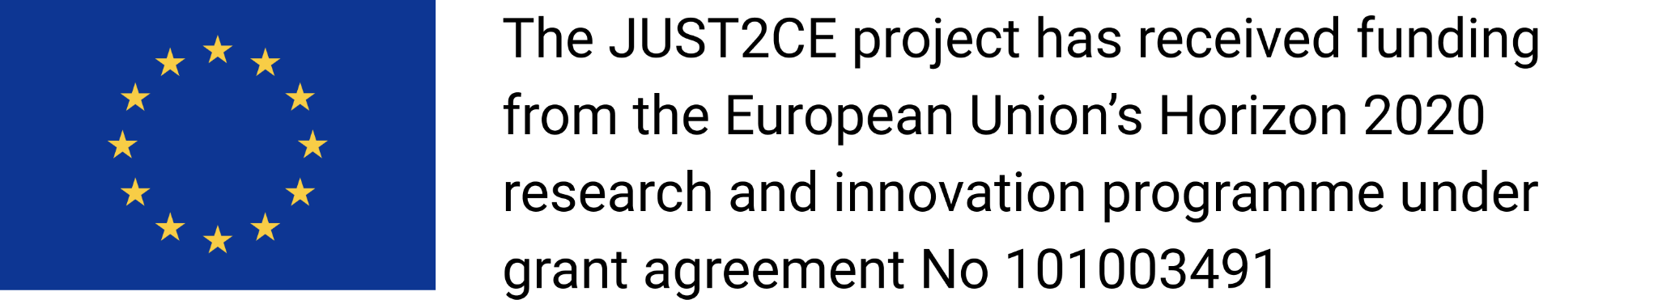

## PROJECT No. 101003491

Just2ce will assess the current state of transition towards the circular economy in relevant economic sectors and analyse possible transition scenarios, as well as their outcomes and impacts. It will identify the key factors that can stimulate or hinder this transition. Natural resources are extracted and transformed into products, which are eventually discarded. As many natural resources are finite, it is important to keep materials in circulation for as long as possible. This makes the transition to circular economy more vital than ever but is a responsible, inclusive, and socially just transition to a circular economy possible or even desirable? What technical, political, and social factors can enable or hamper such transformation? The EU-funded JUST2CE project will answer these questions. It will explore the economic, societal, gender and policy implications of the circular economy paradigm. The project’s findings will shed light on how to ensure democratic and participatory mechanisms when designing and managing such technology.

#### 

#### History Chart

|  |  |  |
| --- | --- | --- |
| **Version** | **Date** | **Implemented by** |
| **V2.0** |  |  |
| **V1.1** |  |  |
| **V1.0** | 31/01/2024 | J.B.R.T. Fevereiro, A. Genovese, O. Vallès Codina, M. Veronese Passarella |

#### Disclaimer

*No part of this document may be reproduced and/or published by print, photoprint, microfilm or any other means without the previous written consent of the JUST2CE consortium. The content of this deliverable does not reflect the official opinion of the European Union. Responsibility for the information and views expressed herein lies entirely with the author(s).*

##### Version: 1.0

# Executive Summary

This study employs an empirically calibrated ecological two-area input-output stock-flow consistent model to analyse various circular economy (CE) policies and practices and their impacts on economic, social, and environmental variables. The research concludes that solely relying on shifts in the behaviour of households and private businesses is insufficient to achieve a just green transition. Two key reasons support this conclusion: competition forces driven by private interests may yield unintended consequences, and there is no universally optimal state for CE policies, each involving trade-offs. Therefore, government intervention is crucial. Coordination among national governments is paramount to prevent policies in one area from negatively affecting others. Additionally, a democratic planning system may empower public authorities to pursue the most pressing targets effectively. The findings indicate that CE policies generally lead to small negative impacts on value added, although exceptions exist, such as reductions in consumption levels in the EU or shifts towards service consumption, which can increase value added. CE policies tend to decrease CO2 emissions and material extraction, demonstrating their potential for environmental sustainability. However, their effectiveness varies depending on consumption patterns and production processes. While CE policies typically result in small negative impacts on employment, certain policies, such as those promoting the use of recycled inputs, may increase employment despite declines in value added. Positive economic effects are observed for female employment in CE policies oriented towards the care economy and social reproduction. The study also highlights changes in functional income inequality, government deficit, and current account balance resulting from CE policies, emphasizing the importance of considering distributional and macroeconomic implications, especially for countries in the Global South. Overall, the findings underscore the necessity of government intervention and policy coordination to achieve a just green transition, ensuring equitable outcomes across economic, social, and environmental dimensions.

# Table of Contents

Executive Summary 4

Table of Contents 5

List of abbreviations 6

[1] Introduction 7

[1.1] Background and objectives 7

[1.2] Scope and limitations 7

[2] Literature review 7

[2.2] CE scenarios 7

[2.2] IO-SFC Models 10

[3] Methodology 11

[3.1] Model’s features 11

[3.2] Economic and Financial Block 11

[3.3] Social Block 12

[3.4] Ecological Block 13

[3.2] Data collection and analysis 13

[3.3] Baseline and alternative scenarios 16

[4] Findings 20

[4.1] Key results 20

[4.2] Discussion of results 24

[5] Final Remarks 25

References 27

Appendix A– Memo: Model Equations 30

Tables and Figures 45

Appendix C– CE Scenarios 50

# List of abbreviations

|  |  |
| --- | --- |
| **BSM** | *Balance-Sheet Matrix* |
| **CE** | *Circular Economy* |
| **IO** | *Input-Output* |
| **IOM** | *Input-Output Matrix* |
| **PFM** | *Physical Flow Matrix* |
| **PSM** | *Physical Stock-Flow Matrix* |
| **SFC** | *Stock-Flow Consistent* |
| **TFM** | *Transactions-Flow Matrix* |

# 

[1] Introduction

[1.1] Background and objectives

In recent years, the concept of circular economy (CE) has gained significant attention as a means to address pressing environmental challenges while fostering economic growth and social equity. The transition to a CE entails rethinking traditional linear production and consumption models to minimize waste and maximize resource efficiency. To evaluate the potential of CE policies and practices, this paper employs an empirically calibrated two-area input-output stock-flow consistent model. The aim is to assess the impact of these policies and practices on economic, social, and environmental variables, with a focus on achieving a just green transition. The primary objective of this paper is to analyse the effectiveness of various CE policies and practices in achieving sustainable economic development while minimizing environmental degradation and promoting social equity. Specifically, the paper aims to:

* Evaluate the economic impacts of CE policies on value added, employment, and income distribution.
* Assess the environmental implications of CE policies, particularly in terms of reducing CO2 emissions and material extraction.
* Investigate the social dimensions of CE policies, including their effects on gender equality and income inequality.
* Examine the macroeconomic consequences of CE policies, such as changes in government deficit and current account balance.
* Highlight the importance of government intervention and policy coordination in driving the transition to a just green economy.

[1.2] Scope and limitations

While this paper provides valuable insights into the potential benefits and challenges of implementing CE policies, it is essential to acknowledge its scope and limitations. Firstly, the analysis is based on a two-area input-output model, which may not capture all nuances and complexities of real-world economies. Additionally, the study focuses primarily on the European Union and the rest of the world, limiting its generalizability to other regions. Furthermore, the analysis assumes certain behavioural responses to CE policies, which may vary in practice. Finally, the study does not account for potential feedback effects or dynamic adjustments over time, which could influence the long-term outcomes of CE initiatives. Despite these limitations, we believe that our findings may contribute to our understanding of the potential pathways towards achieving a more sustainable and equitable economy through circularity.

[2] Literature review

[2.2] CE scenarios

The term ‘circular economy’ (CE) lacks a universally accepted definition, but various definitions share a common theme of decoupling natural resource extraction and use from economic activity, with increased resource efficiency and reduced demand (Bocken et al., 2016; McCarthy et al., 2018). This concept contrasts with the conventional linear economic system, emphasising the closure of resource loops. The transition to a circular economy holds potential for re-industrialization, job creation, and economic growth, offering new opportunities across industries, including secondary material production, repair and remanufacturing, the service sector, and the sharing economy.

Despite substantial attention in scientific literature, a comprehensive systematic review of key contributions on circular economy practices and strategies, considering macro-level societal impacts beyond aggregate employment, is lacking (McCarthy et al., 2018). An exception is the work by Bimpizas-Pinis et al. (2022), who conducted a systematic analysis using the SCOPUS database, identifying nearly 50,000 articles and narrowing it down to 405 relevant ones. It turns out that, among macroeconomic models, input-output (IO) models emphasise the CE concept the most, followed by non-CGE macroeconomic models and system dynamics. While CGE models scenario analyses tend to focus more on ‘Resource Efficiency’ and ‘Resource Waste Management’ strategies through tax policies, IO models tend to focus on a broader set of CE strategies, such as product life extension and closing the supply chain loop.

It turns out that, among macroeconomic models, input-output (IO) models emphasise the CE concept the most, followed by non-CGE macroeconomic models and system dynamics. The typology proposed by Aguillar-Hernandez et al. (2018) categorizes CE strategies simulated in the literature. CGE models scenario analyses tend to concentrate more on ‘resource efficiency’ (RE) and ‘resource waste management’ (RWM) strategies. These strategies are often implemented through tax policies. In contrast, IO models have a broader focus. They encompass a wider range of CE strategies, such as ‘product life extension’ (PLE) and ‘closing the supply chain’ (CSC). In general, results in the literature tend to advocate that adoption of CE strategies can produce ‘win-win’ situations, i.e. reduction in environmental impact coupled with positive socio-economic impact[1]. However, as argued by Fevereiro et al. (2023) results are intrinsically related to the assumptions embedded in each modelling framework and the size of relative changes in technical coefficients, demand composition and required investment needed assumed by each specific scenario simulated.

Among recent works in this line of research, we can highlight the contributions by Wiebe et al. (2019) and Donati et al. (2020), who use environmentally extended multi-regional input-output model, with exogenous final demand model (among other interventions) the impacts of PLE practices in the environment and in socio-economic variables. Both papers find a reduction in environmental impacts. However, while Wiebe et al (2019) report a small positive impact in employment, while Donati et al. (2020) finds negative impacts in employment and GDP. Product lifetime extension practices slow down resource depletion by lengthening the useful life of a product, e.g. changing the way products are designed, improving resistance of materials and components, and facilitating maintenance and repair. These can affect durable consumption goods and (or) capital goods. The direct impact of these change is a reduction in consumption and (or) investment for these goods. However, to make increase the lifetime goods may require more (or larger quality) material inputs and (or) increased expenditure on repair and maintenance. This can help make sense of the of the differences in results obtained by Wiebe et al. (2019) and Donati et al. (2020), as the former study assumes that all saved expenditure on durable goods is diverted to repair and maintenance services, while the latter assumes that only a fraction is diverted to repair and maintenance services.

Increased resource efficiency, as it reduces material consumption can also be considered as CE strategy. In terms of scenario modelling, technological changes that increase the material efficiency in production can be represented as a reduction in the amount of material inputs. Different studies make varying assumptions regarding whether material efficiency gains can be obtained without any additional expenditure in other services, such as consulting or R&D, or through higher investment in new vintages of fixed capital goods. For instance, Meyer et al. (2007) uses a Macroeconometric input-output model to simulate the effect of a linear increase in material efficiency in production in Germany over a period of 11 years. However, this is due to an increase in expenditure in consulting costs and in investment in fixed capital, which is worth 6 years in material costs savings. Wiebe et. al (2019) assume that reduction in material costs are completely offset by increased expenditure with (R&D), thus total demand is kept constant. Donati et al. (2020) do not include any compensating increase in technical coefficients from consulting or increased investment, finding a negative impact on the socio-economic variables considered; contrarily, Meyer et. al. (2007) and Wiebe et. al (2019) find positive impacts.

A key point in difference between methodologies is the assumption regarding to market structure. Most Neoclassical CGE models, such as Skelton et al. (2020), assume full pass-through of cost savings to prices, in line with the perfect competition assumption. Other approaches allow for imperfect competition, such as the Macroeconometric IO models proposed by Giljum et al. (2008), Meyer et al. (2012) and Distelkamp and Meyer (2019) who, based on empirical estimates, derive only a partial pass-through. As such, part of the cost efficiency gains are redistributed as higher value added per unit of output (v), either as higher wages, profit, or tax rates.

Most CGE studies have been applied to analyse the impact of environmental taxes to stimulate shifts in consumption and production patterns that lead to higher resource efficiency. Hatfields-Dodds et al. (2017) simulate the impact of a resource extraction tax, estimating impacts. While Schndal et al. (2106) analyse the impact of different global carbon prices, results indicate negligible impacts on GDP and employment, compatible with a slow-down material use and reducing carbon emissions. Ljunggren Soderman et al. (2016) and Brusselaers et al. simulate changes in tax rates, such as reductions VAT in services relative to manufactured goods, in Sweden and Belgium respectively. Despite similarities in the policies simulated, Ljunggren Soderman et. al. (2016) report a fall in GDP (-0.1%), while Brusselaers et al.(2022) report an increase (1.6%). Both papers find that the tax policies lead to significant reductions in emissions. This result can be linked to the type of consumption functions adopted in CGE models being more or less sensitive to relative price changes (substitution effect). In general the higher the (cross-)price elasticity of demand the higher the shift in consumption away from resource intensive manufactured goods, which become relatively more expensive. In a CGE model with a Keynesian ‘closure’ results might differ, as consumption tend to be more affected by income effects than by substitution effects (changes in relative prices). However, no CGE model adopting a Keynesian ‘closure’ was found in the review process.

Nevertheless, some studies use a Macroeconometric IO framework with a more Keynesian inspiration such as Giljum et al. (2008), Meyer et al. (2012) and Distelkamp and Meyer (2019) model the impacts of the combination of increased resource efficiency with a range of environmental taxes. Although the effect of taxes tend to be much stronger in CGE than in MEIO models, all indicate that the introduction of such policies reduce economic activity and environmental impacts. Hence, results indicate that both policies can deliver a substantial reduction in environmental impacts, without reducing economic activity, if well-coordinated.

CSC practices imply replacing materials from virgin sources with secondary ones through recycling, reuse, and remanufacturing strategies. One key assumption for results in these cases is the difference in prices between recycled inputs and re-used or remanufactured products. Cooper et al. (2016), among other CE practices, estimate positive employment impacts in the UK of an increase the use of re-used of steel sections in the UK. The study assumes a 10% (25/kt) of steel sections extracted from demolition sites in the UK in 2011 can be reused, and that prices of re-used steel sections are 50% (£225/t) cheaper than those based on primary raw material (£450/t). Final demand is kept constant as such the analysis don’t capture secondary rebound effects associated with potential induced income effects on employment.

Peng et al. (2019) CGE model analyse the impact of stimulating the use remanufactured engines in China by comparing scenarios of using a (i) government a subsidy in the purchase of remanufactured engines; (ii) an increase in the energy efficiency of remanufactured engines of 15%; and (iii) of combining the two measures. Results indicate that, while the subsidy lowered prices of re-manufactured engines considerably and had a positive, although small, effect on GDP, increased energy efficiency in remanufactured engines had almost no impact on prices and, consequently, it did not affect GDP. Winning et al. (2017) use a CGE model to consider the effects of a doubling in steel scrap availability worldwide. Results point to minor gains in GDP and lower environmental impacts at a global level. However, there are important regional imbalances, with negative GDP effects for commodity exporters from the global south.

Papers from the RWM category have typically analysed environmental and socio-economic impacts of alternative waste disposal strategies, such as landfilling, incineration and recycling. Ferrao et al.(2014) assesses the environmental and socioeconomic impact (in terms of gross value added, employment, wages and total revenue) of the Portuguese packaging waste management system by means of a WIO and a IO multiplier analysis. Authors conclude that moving up the waste hierarchy – from landfilling to recycling – creates jobs and boosts the economy. Freire-Gonzalez et. al (2022) analyse, through a CGE model, the impact of incineration and landfill taxation in the case of Spain; modelled through different waste tax tariffs and including subsidies to recycling activities. Contrasting scenarios where (a) only the extension of the waste tax, or (b) waste tax revenues are used to subsidize recycling activities allows the author to assess the differences in impact revenue recycling schemes of environmental taxation. Results show that although both scenarios yield negative GDP results, despite better outcomes in the revenue recycling scenario.

One last important aspect of CE scenarios modelling is to analyse different scenarios analysing whether the CE policy is adopted by the entire world or only one (or some regions), comparing the results. Diestelkaamp and Meyer (2019), for instance, analyse three different types of transition – ‘global cooperation’, ‘EU-goes ahead, and ‘civil society leads’ – to a resource-efficient and low-carbon production in EU-25 countries through different policy mixes. In the ‘global cooperation’ scenario, all countries co-operate through international agreements on harmonised economic and regulatory policy instruments. Results indicate that it is possible to achieve an absolute decoupling of GDP and environmental impacts globally, without reducing GDP growth relative to the baseline scenario. Both in the ‘EU goes ahead’ and in the ‘civil society leads’ scenarios, the EU pursues a low-carbon, resource-efficient economic strategy unilaterally. However, in the ‘EU goes ahead’ scenario change is obtained through strong EU-level economic and regulatory policy instruments instituted by the member-states. By contrast, in the ‘civil society leads’ scenario, resource-efficiency is driven by voluntary changes in preferences and behaviours of European consumers and businesses, such as a reduction in working-hours (through an increase in the share of part-time employment) and a reduction in the average propensity to consume of households. These voluntary behavioural changes end up affecting negatively GDP growth relative to the baseline scenario, whereas the GDP is shown to increase under the ‘EU-goes ahead’ scenario. Overall, the last two scenarios shows that a joint effort of EU member-states could suffice to achieve an absolute decoupling of their material footprint from economic growth, independently of what the rest of the world does.

As reviewed in this section the macroeconomic modelling literature on environmental and socio-economic impacts of CE strategies scenarios has been developing fast, with a range of frameworks and scenarios being analysed. Our work intends to contribute to this literature, by analysing CE scenarios using a new macroeconomic modelling framework, using a two region Input-Output SFC (IO-SFC) model developed within the JUST2CE project. In the next section we provide a brief overview of this methodology and the emerging literature on ecological IO-SFC models.

[2.2] IO-SFC Models

In recent years, several authors (e.g., Hardt and O’Neill 2017; Bimpizas-Pinis et al., 2023; Fevereiro et al., 2022, 2023) have identified the combination of input-output (IO) analysis and stock-flow consistent (SFC) modelling as the most promising approach for developing models assessing the economy-ecology nexus, including Circular Economy (CE) transition scenarios.

As is well known, IO models are analytical tools used to represent and quantify the interdependencies between different industries of a capitalist economy (e.g., Leontief 1936, 1941). More specifically, IO models illustrate how changes in one industry, such as increased production or consumption, affect other industries through a system of interconnected inputs and outputs, providing insights into the overall economic impact of alternative shocks and policies.

On the other hand, SFC models can be considered a specific class of ‘system dynamics’ tools that replicate the dynamics of a financially sophisticated economy (e.g., Godley and Lavoie 2007, Caverzasi and Godin 2015, Nikiforos and Zezza 2017). In the last decade, SFC models have gained traction in ecological macroeconomics too, due to their ability to integrate consistently and comprehensively the flows and stocks of the real economy, the financial sector, and the ecosystem (Dafermos 2017, 2018; Carnevali et al., 2019, 2020, 2023).

Due to the complexity of an integrated approach, only a few attempts have been made so far to include explicitly the IO structure of the economy into an SFC dynamic model (e.g., Berg et al., 2015, Valdecantos and Valentini 2017). However, progress has been made in recent years. Notably, Veronese Passarella (2022) has transformed a standard ‘aggregative’ SFC model into a model that disaggregates the economy both vertically (by social sectors) and horizontally (by production industries). The model is then used to analyse simple CE scenarios. More recently, Fevereiro et al. (2023) have expanded on Veronese Passarella (2022)’s analysis by applying it to a two-area economy. This extension explicitly considers the effects of international trade, supply-chain interdependencies, cross-border portfolio investments, and exchange rate fluctuations.

In Section 3.1, we outline the main features of the model. The complete set of accounting identities, equilibrium conditions, and behavioural equations is provided in the Appendix, while model identification is discussed in Section 3.2. Alternative transition scenarios are outlined in Section 3.3 and thoroughly presented in Section 4.

[3] Methodology

[3.1] Model’s features

We employ an empirically calibrated ecological open-economy input-output stock-flow consistent dynamic model to design and evaluate various circular economy policies and practices.

* First, the model is *dynamic*, allowing for reproducing the emerging behaviour of the system over time.
* Second, the model is *stock-flow consistent*, meticulously defining the relations between stocks and their related flows, expressed in monetary, real, and even physical terms.
* Third, the model has an *input-output* structure, accounting for cross-industry interdependencies in the production sector within each area and across areas.
* Furthermore, the model is an *open-economy* model, dividing the world economy into two areas: the European Union and the rest of the world.
* The model is also *ecological* as the relationships of economic and social variables with the ecosystem are explicitly modelled.
* Lastly, the *empirical calibration* implies that model’s coefficients are calculated based on available time series data (e.g., technical coefficients) or defined to match current observed values of key variables (e.g., GDP components) for the two areas considered.

In formal terms, the model comprises a system of accounting identities and difference equations that describe the relationships between socio-economic sectors and between industries. Ideally, the model structure is subdivided into three major blocks, concerning the economy, the society, and the ecosystem, respectively.

[3.1.1] Economic and Financial Block

Each area consists of five domestic macroeconomic sectors: a) households; b) private production firms; c) the government sector; d) commercial banks; and e) the central bank. Each area shares the same pre-institutional economic structure, and there are no barriers to trade or restrictions on capital flows in the baseline scenario.

Households (equations A.1 in the Appendix, 1-5) receive both labour incomes (wages) and capital incomes (distributed profits, capital gains, and interest payments). They purchase a variety of services and consumption goods based on their disposable income and net wealth. In addition, they can acquire personal loans to fund the purchase of durable goods or to cover consumption exceeding their current disposable income. Households’ net savings consist of cash (currency), bank deposits, domestic government bills, foreign government bills, domestic shares, and foreign shares. Their portfolio investment decisions are based on Tobinesque principles, as they depend on the relative return rates of financial assets and liquidity preference. Firms manufacture goods and services that are offered for sale in the market. As such, households’ consumption is dependent on their disposable income and net wealth. Households consume a fixed proportion of their disposable income, and, as such, it is assumed to be independent of changes in the interest rate. However, interest rate changes may affect consumption indirectly through its effects on net wealth.

To carry out their production, private firms (equations A.2 in the Appendix, 6-14) require labour (currently assumed to be homogenous by skill level), inputs (which will be consumed throughout the production process in each year) and fixed capital goods (purchased as final demand investment). Following the input-output structure, the model assumes the firms’ production function with constant returns to scale, without substitution possibilities between factors of production (labour and fixed capital) and between inputs, in the baseline scenario. Firms in each sector use a single technology to produce a homogenous product. Private firms use a markup rule over costs to set prices. More precisely, they set industry-specific costing margins over their unit costs of production, including fixed capital costs. However, actual market prices are allowed to fluctuate above or below the prices of production if demand is higher than potential output.

Private firms demand for fixed capital determines real gross private investment (equations A.3 in the Appendix, 15-24). It is assumed that each industry has its own capital requirements and, as such, set a target stock of fixed capital which is dependent on the level of total output (i.e., firms target to keep a constant capital-output ratio). Moreover, fixed capital goods are assumed to depreciate at a constant rate. Therefore, in each period, industries must undertake a positive real private gross investment to keep the capital stock level adjusted to the target, even when total output remains constant. When total output increases, industries increase their real gross investment expenditure in order to gradually adjust their stock of capital goods to the target level. In order to fund its investment plans, private firms rely on amortization funds (retained profits), loans (obtained from domestic banks) and issuance of shares (which can be bought by domestic and foreign households). Unretained profits is distributed as dividends to households.

Real government consumption (equations A.5 in the Appendix, 30-44) grows according to an exogenous rate, reflecting the pollical nature of the variable. Government also undertakes public investment, which is exogenous, and capital goods are assumed to depreciate at a constant rate, like it happens with private investment. To fund its expenditure based on revenue obtained from income taxes paid by households on their labour and non-labour income, VAT, import tariffs and any profits obtained by the central bank. The government issues government bills whenever it runs a budget deficit - meaning its spending is higher than its revenues. The interest rate on government bills is determined based on a mark-up over the policy rate set by the central bank, based on its monetary policy objective. Central banks are responsible for issuing the currency of each area and supply cash on demand, implying that it buys any government bills that the private sector does not wish to hold. In addition to domestic government bills, central bank of zone 2 would also hold foreign bonds in its balance sheet.

Commercial banks (equations A.4 in the Appendix, 25-29) supply loans on demand, meaning that commercial banks are always ready to finance firms’ production plans and to fund private investment and consumption expenditures, implying that there is no credit rationing. They pay an interest rate on deposits held by households. The interest rate on loans and deposits is also determined based on a mark-up over the policy rate set by the central bank, with interest rates charged on loans being set higher than those paid for deposits. When deposits collected by the banks may exceed those created by granting loans to the firms, commercial banks hold government bills as the asset counterpart of extra-deposits. Conversely, if loans exceed deposits, banks request (and obtain) advances from the central bank.

The baseline scenario involves four traditional industries (manufacturing, agriculture, services, and waste management), where three outputs (and waste) are produced using the same products as inputs, while in the Circular Economy scenario, part of the waste is diverted to the recycling industry and is re-processed into inputs which substitute inputs originally obtained from traditional industries.

[3.1.2] Social Block

While households are treated as an aggregated sector, the model enables the tracking of income and wealth distribution dynamics, both pre- and post-tax. This distinction allows for the differentiation of policies and shock effects on income flows for wage earners and rentiers (equations A.6 in the Appendix, 45-52).

In this preliminary version of the model, the unemployment rate is a linear function of labour demand by production firms in each industry and area. The population, and consequently the available labour force in each area, is determined by an autonomous growth rate and net immigration inflow. Cross-area immigration, in turn, is influenced by three factors:

* the population size of the other area (larger population leading to a higher outflow of workers);
* the unemployment rate in the other area (higher unemployment motivating workers to leave their own area);
* the wage difference between the two areas (higher wages attracting workers from the other area).

Additionally, high-salary industries are assumed to be male-dominated (Blau and Kahn, 2017). This results in a tendency for female workers to be concentrated in lower-salary industries, even when other factors are equal. This threefold division of the labour force, albeit simplified, facilitates an intersectional analysis of social discrimination in relation to various shocks and policies.

[3.1.3] Ecological Block

The model includes a set of ecological equations that resemble those utilised in recent literature on ecological SFC models (see Dafermos et al., 2017, 2018; equations A.11 and A.12 in the Appendix, 82-104). Firstly, waste is generated in each industry during the production process. In the baseline scenario, traditional waste management is among the industries considered. However, when circular economy policies are implemented (as detailed in section 6), a recycling-reuse-repair industry is introduced as a one-off process innovation by changing the input-output coefficients accordingly (see Appendix A.13).

Secondly, another undesirable output of production is industrial CO2 emissions. These emissions are contingent upon the quantity of non-renewable energy utilised. In turn, this non-renewable energy use is a direct linear function of the industry-specific energy-intensity coefficient, the industry’s specific percentage of non-renewable energy, and a uniform CO2 intensity coefficient of non-renewable energy.

Thirdly, the model gauges the impact of anthropogenic production on atmospheric temperature. This impact is determined by global CO2 concentration in the atmosphere, the non-CO2 fraction of total anthropogenic forcing, and the transient climate response to cumulative carbon emissions.

Fourthly, both matter and energy resources are depleted with the production of new goods (and services). The amount of matter extracted depends on both the produced output in each industry and the quantity of socioeconomic stock that is recycled in each period.[2] Likewise, energy from renewable sources can be regenerated periodically, whereas non-renewable energy becomes dissipated. Lastly, matter and energy reserves expand as new resources are converted into reserves and contract as natural reserves are employed for production purposes.

[3.2] Data collection and analysis

The model is coded and simulated in an *R* environment. Data have been retrieved from Exiobase 3*.* More specifically we retrieved data from EXIOBASE 3 for the base year of 2011, which contains multiregional input-output data disaggregated for 164 sectors for 45 countries and 4 rest of the world regions 164 products. To make the data compatible with the model structure, the data was aggregated into two regions, European Union (defined as Zone 1) and the rest of the world (Zone 2); and to 5 sectors, namely Agriculture, Manufacturing, Services, Waste Management Services, and an aggregate CE sector. The CE aggregated sector contains the 13 reprocessing manufacturing sectors (existent in EXIOBASE 164-sector disaggregation); the recycling of waste and scrap and recycling of bottles by direct re-use sectors[3].

From Exiobase 3 some variables were used to calibrate parameters regarding the structure of the economy. These include variables like technical coefficients, real wages, labour productivity which are essential to calculate unitary costs of production and, therefore, obtain production prices. We also take from Exiobase 3 sectoral shares in employment (with a sectoral breakdown by gender) and final demand components (such as private consumption, investment government consumption, exports and imports), and sectoral coefficient of CO2 emission and material use.

Other variables describing the overall size and composition of the economy (such as total output, GDP, final demand components and trade flows) were also taken from EXIOBASE but were used as targets to be reached in the calibration of the model baseline. The target values of these variables are presented on Table X below.

Table 1: Target variables values

|  |  |  |  |  |  |  |  |
| --- | --- | --- | --- | --- | --- | --- | --- |
|  | Consumption | Investment | Government | Exports  of final goods | Imports  of final goods | GDP | Gross Output |
| EU (Area 1) | 626.32 | 245.77 | 239.46 | 102.78 | 66.36 | 1130.67 | 2153.60 |
| RoW (Area 2) | 2370.71 | 1135.84 | 675.33 | 66.36 | 102.78 | 4162.75 | 8424.52 |

Note: Values are expressed in €10 billion euros. Source: Author’s own elaboration based on EXIOBASE 3.

The remaining coefficients and variables have been calibrated. For this purpose, we identified a number of parameters and exogenous variables to be used as *instruments*. An evolutionary random-search algorithm was developed to assign values to those instruments in such a way as to minimize the gap between the values of endogenous variables under our model’s baseline scenario – that is, our *targets* – and the observed data.

The remaining step in the empirical calibration of the model consists of finding a baseline set of instrumental variables $x_{i}$ that ensure the steady state of the system is located on the expected values of target variables $y_{i}$ for both regions 1 and 2 starting from initial conditions equal to zero. Table 1shows the target values of a total of 14 variables, with 7 variables per region, shown in table 1. Initial balance sheets configurations (i.e. initial combination of stocks of assets and liabilities) can also be tested as instrument variables.

Then, the goodness of fit $R$ can be defined as:

$$R=\frac{1}{N}\sum_{i=1}^{N}{{\left(\frac{y_{i}}{⟨y_{i}⟩}-1\right)}^{2}}$$

where $y_{i}$ and $⟨y_{i}⟩$ are the observed and expected values for target variables $i=1,...,N$, so that the goodness-of-fit ratio for variable $i$ is

$$\frac{y_{i}}{\left\langle y_{i}\right\rangle }$$

with an expected value $\left\langle \frac{y_{i}}{\left\langle y_{i}\right\rangle }\right\rangle =1$.

According to this definition, a better fit, with $y_{i}$ are closer to expected values $⟨y_{i}⟩$, has $\frac{y_{i}}{⟨y_{i}⟩}$ ratios closer to 1 and a lower value for $R$ indicates a better fit, where $R=0$ is the perfect fit. As a first step in the algorithm, an initial simulation $k=1$ is run from a specific set of initial parameters and variables, $x_{1}$ and its goodness of fit $R_{1}$ is computed. Then, at each step $k$ of the algorithm, a simulation is run slightly changing the initial set of parameters and variables from a random Gaussian distribution with average $x_{k}$ and standard deviation $σ$ as hyperparameters,

$$x_{k}=N\left(x_{k-1},σ^{2}\right)$$

computing new goodness of fit $R_{k}$. Then, the algorithm accepts the new set of parameters of values $x_{k}$ if the goodness of fit improves, $R_{k}<R_{k-1}$, and proceeds to the next iteration $k+1$ until the goodness of fit reaches a reasonable and satisfactory value for the particular target variables. New target variables of interest can be added in order to further expand and sophisticate the goodness of fit. Figures 1 and 2 visualize a particular sample run of the random-search algorithm for the instrument variables $x_{k}$ to stabilize the government deficit and public debt, which added initial values of the balance sheet to the instrument variables:

Figure 1: Calibration of instruments



With this process, we find empirically meaningful and realistic baselines on which the experiments can be conducted. Additional constraints have been applied to ensure the realism of values attributed to instruments and the achievement of a quasi-steady-state condition at the period the economy is shocked by the implementation of CE related policies, such as, for example, restricting marginal propensity to consume out of profits and out of wealth to values below the marginal propensity to consume of workers ($α_{1}>α_{2}>α_{3})$ (Kaldor, 1955-56).

Figure 2: Goodness-of-fit ratios for selected targets



Before implementing a policy scenario analysis, it is essential to stabilize the model, ensuring that no further changes occur in relevant variables such as GDP, total output, current account balance, and government deficit. At the same time, it is necessary to obtain economically relevant values for non-targeted variables, verify the stability of balances between institutional sectors (households, non-financial corporations, banks, government, and central bank), and ensure coherence in stock-flow norms of variables analysed within the Balance Sheet and TFM tables (included in Appendix B). This ensures that the outcomes of shocks are not influenced by ongoing trends but can be attributed solely to the effects related to the scenario shock.

To achieve this, parameter values are further adjusted to balance calibration fitness and model stability. Table 2 presents the target ratios used in the model simulations. Overall, the model demonstrates a good fit to observed values for the selected variables, with an overall fitness statistic of 0.02. However, there is room for improvement with additional work. Specifically, the fit of investment in both regions can be enhanced, as the current model calibration generates only 74.9% of the observed total (private + public) investment for the EU (Zone 1) and 70.2% for the Rest of the World (RoW, Zone 2) compared to the values in the Exiobase 3 input-output tables.

Additionally, consumption in the EU is currently being overestimated in the model calibration (117.2% of the target value), leading to a slight overestimation of EU imports of final goods (108.3%). While the fit of Gross Output for the EU is satisfactory (101.5%), there is a slight underestimation for the Rest of the World, with the model estimating only 90.9% of the observed value. This discrepancy has implications for the estimation of total employment and environmental impacts in the model baseline, which will consequently be slightly underestimated in the initial period of the shock.

Table 2: Target ratios of the calibration relative to observed values (2011)

|  |  |  |  |  |  |  |  |
| --- | --- | --- | --- | --- | --- | --- | --- |
|  | Consumption | Investment | Government | Exports  of final goods | Imports  of final goods | GDP | Gross Output |
| EU (Area 1) | 1.172 | 0.749 | 1.000 | 0.997 | 1.083 | 1.164 | 1.015 |
| RoW (Area 2) | 0.998 | 0.702 | 1.000 | 1.083 | 0.997 | 1.055 | 0.909 |

Note: A value of 1 indicate that in period 75 (when the policy shocks are introduced) the size of the economy projected by the model is equal to the data retrieved.

To initialize the model, a shock to an exogenous variable is selected to initiate the model. In our case, government consumption and investment were chosen, constituting 100% of government consumption and 20% of total investment targets in each area. In the baseline scenario, this generates a 20% debt-to-GDP ratio for the EU, while the rest of the world has a debt-to-GDP ratio of 15%. This is lower than the current observed stock of debt (for example, the overall debt-to-GDP ratio of European Union countries, which has fluctuated around 80% in the past decade before the pandemic). Therefore, this aspect requires further attention in subsequent rounds of model calibration and scenario analysis, to be conducted in the next few months.

[3.3] Baseline and alternative scenarios

Figures below depict a specific simulation run displaying a rapid dynamic transition to the steady state, with the model stabilizing after 30 periods. The figures also illustrate a reasonable goodness of fit for the target variables in both regions, as well as selected aggregate economic indicators. Additionally, industry-level labour-market indicators, including empirical values for gender employment shares, and empirically calibrated ecological indicators are included. Monetary variables are denoted in tens of billions of euros.

Figures 3 to 5 present the results for the calibrated baseline of selected macroeconomic, labour market, and ecological indicators. Figure 3 displays: (i) the current account balance between the two regions (Zone 1 representing the EU and Zone 2 the rest of the world); (ii) total employment; (iii) government deficit; (iv) gross output; (v) real imports (which, considering the 2-regions structure of the model, represent the reverse of each region’s exports); (vi) government bills (government debt stock); (vii) total real consumption; (viii) the trade balance; and (ix) the value added.

Figure 4 presents the results for the calibrated baseline of labour market indicators, including total employment, female employment, the size of the labour force, and the total wage bill.

Figure 3: Simulation of selected macroeconomic indicators.

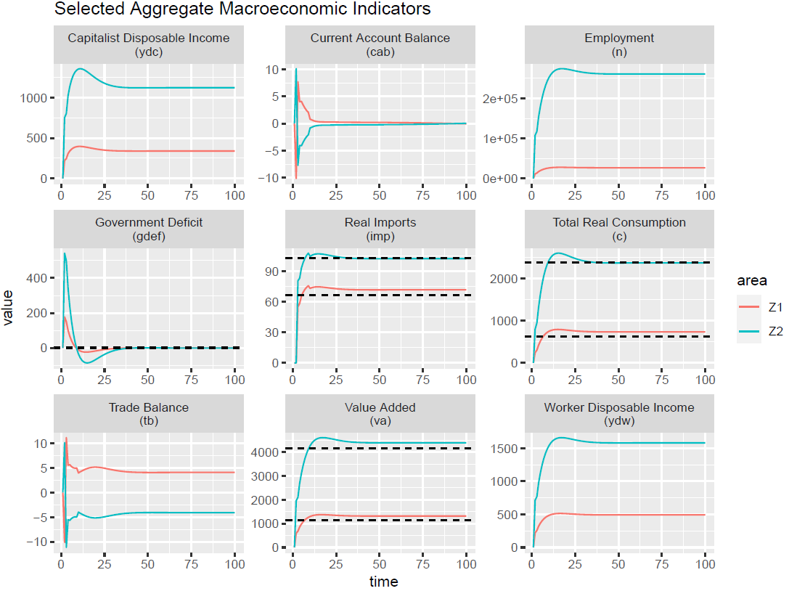

Note: Dashed horizontal line corresponds to the target values.

Figure 4: Simulation of industry-related labour market indicators

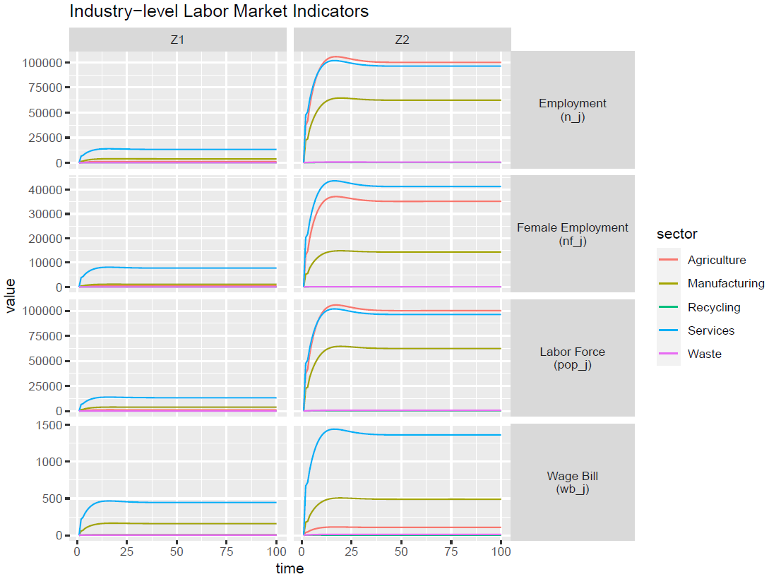

Figure 5: Simulations of ecological indicators

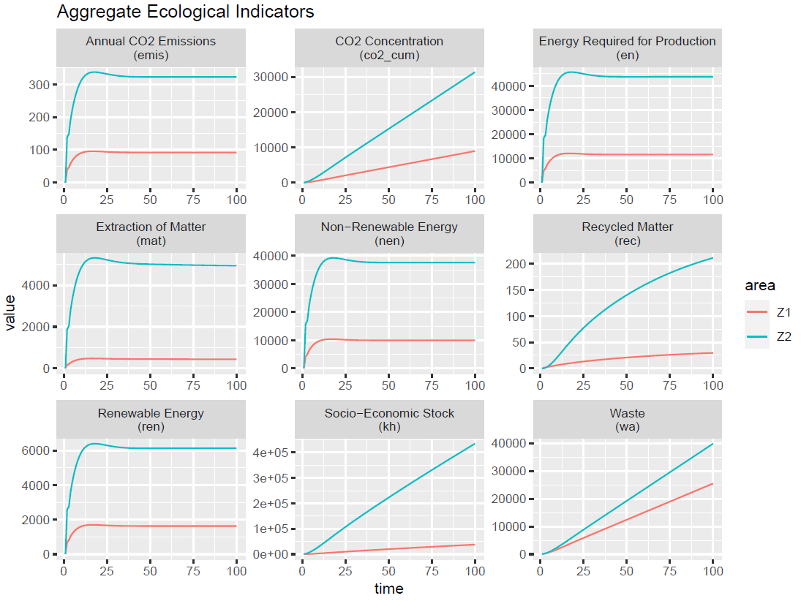

In Figure 5, we track the evolution of the following indicators: (i) CO2 emissions (in kg of CO2 equivalent); (ii) CO2 concentration; (iii) energy required for production (include unit); (iv) extraction of matter (in kt); (v) non-renewable energy used (include unit); (vi) production of material goods (include unit); (vii) recycled matter (in kt); (viii) renewable energy (insert unit); (ix) Socio-Economic Stock (include unit); (x) waste produced. Once the model baseline is empirically calibrated, CE policies can be simulated to assess their impact on economic, social, and ecological indicators.

At the current stage, a table of CE experiments that can be conducted in the model is provided in Table 3. It is divided into three categories: private practices by households and firms, direct government policies, and indirect CE effects from other practices and policies. All scenarios, unless indicated otherwise, are implemented in Zone 1, the European Union, with a common shock intensity *S* for all shocks. For each alternative scenario, the absolute difference and percentage difference between the value of selected variables under the baseline scenario and their value under the alternative scenario at the end of the simulation are computed, providing descriptive informative statistics of the impacts of CE policies and practices on macroeconomic, social, and ecological indicators.

Scenario 1.1 aims to achieve a reduction in consumption level by reducing the marginal propensity to consume out of wages ($α_{1})$, out of profits $\left(α_{2}\right)$ and out of wealth ($α_{3})$. This aligns with a ‘post-growth’ strategy. Scenario 1.2 involves the effects of continuous structural change towards the service sector, changing the sectoral shares in the final consumption vector (${∆β}_{i})$.

In scenario 1.3, to test impacts of product life extension (PLE), we increased the depreciation rate ( $δ)$ of capital goods. This implies a lower investment and, without ancillary changes in higher expenditure in R&D investment or higher spending in consumption of repair services by firms, is expected to lead to lower final demand and income. Scenario 1.4 involves a substitution of primary inputs for recycled, re-processed or remanufactured inputs, by increasing (decreasing) input-output coefficients of CE (other) inputs $(∆a_{CE,j} and↓a_{i,j},for i≠CE$). As such, can be classified as a closing the supply loop (CSC) strategy.

Scenarios 1.5 and 1.6 involve ‘resource efficiency’ measures. Scenario 1.5 implies a higher propensity to consume green through a reduction in waste coefficients (ζ), which involves higher efficiency in packaging and discarding of other inputs materials. Scenario 1.6, a lower extraction rate of matter, involves fewer raw materials being used per unit of output ($↓μ_{mat})$. However, this requires further elaboration with a counter-shock explaining how this change in technology comes about, which should involve increased expenditure in R&D.

Scenario 1.7, a lower discarding rate of socio-economic stock, can also be related to a product lifetime extension (PLE) CE strategy, but it acts on durable consumption goods. However, a compensating increase in demand for repair and maintenance services still needs to be implemented. Scenario 1.8 is related to the energy sector, involving an increase in the share of renewable energies in energy generation. However, as the energy & electricity sector is not disaggregated at this current stage, the input structure does not change.

Scenarios 2.1 and 2.2 involve government fiscal policy. Higher government spending towards efficiency (Scenario 2.1) also entails a substitution of primary inputs for recycled, re-processed, or remanufactured inputs, but this is now a consequence of increased government expenditure ($(∆g$). Scenario 2.2 involves a change in the composition of government expenditure towards the circular economy sector. Lastly, scenario 3.1 involves increased taxation on distributed profit income. It can be combined with other shocks to provide a source of funding for other initiatives.

Table 3: Alternative scenarios and shocks

|  |  |  |
| --- | --- | --- |
| **No.** | **Scenario** | **Shock** |
| **1** | **CE practices by households and firms** |  |
| 1.1 | Reduction in consumption level | Fall in propensities to consume $α_{1}, α_{2}, α_{3}$ |
| 1.2 | Change in consumption composition towards services | Increase in consumption share of services $β_{s}$ at the expense of manufacturing $β_{m}$, and increase in final investment of manufacturing |
| 1.3 | Product lifetime extension | Fall in depreciation rate $δ$ for capital goods |
| 1.4 | Higher recycling rate | Higher input-output coefficients $a_{CE, j}$ |
| 1.5 | Higher propensity to consume green | Fall in waste coefficients $ζ$ |
| 1.6 | Lower extraction (or conversion) rate of matter | Fall in $μ_{mat}$ |
| 1.7 | Lower discarding rate of socio-economic stock | Fall in percentage of durable consumption goods discarded $ζ_{DC}$ by households |
| 1.8 | Higher renewable energy share | Increase in $η_{en}$ |
| **2** | **Direct CE policies by the government** |  |
| 2.1 | Higher government spending towards circular economy efficiency | Increase in $g$, and CE transition to B matrix with smaller IO coefficients |
| 2.2 | More selective government spending towards circular economy efficiency | Increase in $σ_{CE}$ |
| **3** | **Indirect effects on CE from other practices and policies** |  |
| 3.1 | More progressive taxation | Increase in $θ_{c}$ |

Source: author’s own elaboration

The list of scenarios for the transition to a circular economy is still tentative. Modelling some of the scenarios can be further improved by introducing ancillary changes to enhance comparability with other scenarios tested in studies reviewed in literature in section 2. Additionally, combining them with other compensatory policies (e.g., working time reduction, basic income, and/or industrial policies) could be beneficial. Moreover, further CE shocks (and combinations of existing ones) may also be explored, including.

* A higher portfolio share of equity issued by firms producing green or CE-friendly products (e.g. based on average recycling rate of firms in each area, etc.).
* Selective value-added tax favouring green or CE-friendly products or industries (e.g. based on the recycling rate).
* Selective import tariff tax favouring green or CE-friendly products or industries (e.g. based on the recycling rate).
* Gender rebalancing via government spending.
* Changes in immigration flows, population growth rate, and interest policy rate.
* Landfill limits and change capacity.
* Introduction of specific CE sub-industries (such as ‘repairing’ or ‘sharing’) and change its input-output coefficients.
* Government spending to reduce matter and energy intensity ratios.

[4] Findings

[4.1] Key results

In general, CE policies generate small negative impacts on value added, with a few exceptions such as a reduction in consumption level in the EU or a shift in consumption towards services, which increases value added. The former can be attributed to wealth effects leading to higher consumption in the long run, while the latter is associated with lower import coefficients related to the consumption of services relative to agriculture and manufacturing. Consequently, higher value added in the EU comes at the expense of lower value added in the rest of the world.

Environmental impact results, such as CO2 emissions and material extraction, tend to correlate with economic activity and, therefore, decrease in most scenarios in both areas. An exception is scenario 1.2 (Change in consumption towards services), where there is a small decrease in CO2 emissions and material extraction in the EU, despite the increase in value added.

In terms of employment, CE policies also generate small negative impacts, consistent with the decline in economic activity. Exceptions are CE policies involving a shift towards the use of recycled, reprocessed, or remanufactured inputs in production (scenario 1.4 and 2.1), where employment increases despite the decline in value added. This is due to the production processes in these activities being more labour-intensive than in traditional sectors. Female employment levels generally follow the same direction of change as overall employment, albeit with smaller positive or negative changes relative to changes in total employment. Scenario 1.2, where the transition of consumption towards services occurs, is an exception to this pattern. Despite the overall decrease, female employment in the EU actually improves, as women tend to be more represented in service rather than manufacturing employment. This demonstrates the positive economic effects of CE policies oriented towards the care economy and social reproduction.

Changes in functional income inequality are measured as one minus the ratio between workers’ disposable income and capitalists’ income, indicating the gap between the disposable incomes of the two classes. Reductions in this ratio imply a reduction in inequality. In the EU, functional income inequality decreases in scenarios 1.1 to 1.4, as well as in 2.1, but increases in cases of more selective government and more progressive taxation scenarios. In the rest of the world, there are either no impacts or minor increases in income inequality.

Regarding government deficit and current account balance, results indicate a worsening situation for the rest of the world. This is particularly concerning for countries in the Global South, considering ample empirical evidence that the major binding constraint for their development is the balance-of-payments constraint. In these circumstances, if a country is unable to generate enough foreign currency from exports and foreign direct investment to meet its import and financial outflow requirements, a balance of payment crisis may be triggered, especially in countries that already experience large structural trade deficits. This issue is acute in low-income and developing economies, as government debt is typically denominated in foreign currency, creating a vicious cycle between exchange rate devaluation and increases in public debt relative to GDP for affected countries.

Specific private adoption of CE practices among firms and households, simulated in scenarios 1.5 to 1.8, have almost no macroeconomic effect, with limited reduction in environmental impacts. For instance, a higher propensity to consume green or CE-friendly products (scenario 1.5) induces only a reduction in waste. Similarly, a lower extraction rate of matter (scenario 1.6) reduces the amount of waste produced, but also reduces recycled matter. Scenario 1.7, a lower discarding rate of socio-economic stock, also reduces the amount of recycled matter. A higher share of renewable energy (scenario 1.8) shifts energy consumption from non-renewable to renewable sources, resulting in reduced emissions. A more progressive taxation, in the form of an increase in the capital income tax, improves income distribution and emissions, but also reduces employment.

Figures below show the percentage and absolute differences between the value under the baseline scenario and the value under the alternative scenario for selected macroeconomic, social, and ecological indicators. Overall, government-spending policies generally fare better in terms of employment, ecological impact, and international inequality than private changes in behaviour among firms and households, especially in consumption. For instance, private reduction in consumption in the European Union destroys the most employment, especially in the rest of the world, including female employment. Only capital disposable income benefits due to an increase in wealth and public debt; when the shock hits, worker disposable income decreases and then increases only to gradually recover its original value. A change in consumption shares towards services also destroys employment in general, but less. However, it does substantially better in the ecological indicators.

Instead, when the government induces a transition to CE through spending (scenario 1.4, recycling rate increase, Z1_ce = 1), employment increases, especially in the CE sectors. Direct government policies, especially oriented towards spending, also compared to indirect policies, are the best in terms of employment, either in absolute terms (higher government spending) or relative (more selective government spending). Most, if not all, CE policies reduce gross output both in absolute and relative terms, which has a positive impact on ecological indicators but a negative impact on employment. However, this can be compensated with more value added and employment accompanied by more selective government spending in the context of the CE transition. Some CE policies, such as a lower discarding rate for socio-economic stock or extraction of matter, have a much more exclusive impact on ecological indicators. We see evidence of a rebound effect in the context of the CE transition, as it improves resource efficiency.

Figure 6: Summary of percentage differences with baseline scenario by shock

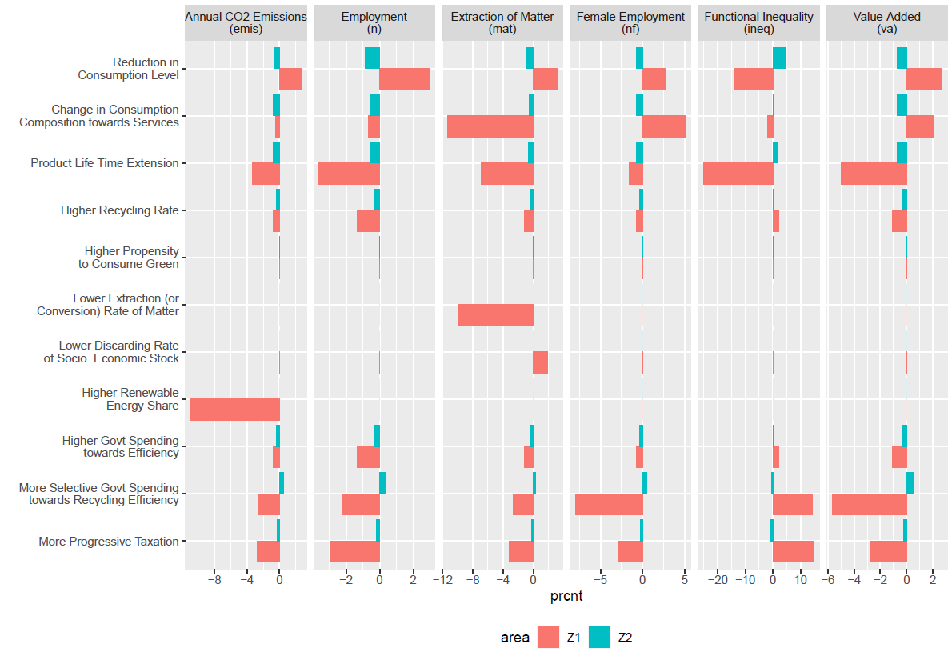

Figure 7: Summary of absolute differences with baseline scenario by shock



[4.2] Discussion of results of specific scenarios

In this section, we delve into more detail on some of the main results of selected scenarios and the associated shocks (1.1, 1.2, 1.3, 2.1, 2.2, and 2.3). Specific private adoption of CE practices among firms and households, simulated in scenario 1.5 to 1.8, have almost no significant impacts. Therefore, their results are not discussed in detail here. A comprehensive compilation of the results of all shocks on various selected macroeconomic, labour market, and environmental variables is included in Appendix C.

**Scenario 1.1 – Reduction in the consumption level in the European Union**

In particular, initial results indicate that a reduction in consumption due to private CE practices (Scenario 1.1) induces a rebound effect in Zone 1 (European Union), leading to an ultimate increase in value-added and employment by 2.7% and 2.75%, respectively, after experiencing an initial negative scenario. Due to this rebound effect, ecological impacts, such as CO2 emissions (+2.4%) and total material extraction (-2.3%), also increase. European Union imports eventually increase over the baseline, worsening its trade balance with Zone 2 (Rest of the World), shifting from an initial surplus to a deficit. Nevertheless, the accumulated net foreign assets by the EU in the transition lead to a continuous deterioration of the current account balance of the Rest of the World (1.1% of GDP), with its government deficit increasing to 1.2% of GDP.

**Scenario 1.2 – Shift in consumption composition towards services in the EU**

In turn, the shift of consumption shares from manufacturing to services (Scenario 1.2) induces no significant rebound effect in the EU. However, value-added increases by 2.1%, while employment is 0.5% lower relative to the baseline. These shocks negatively affect the rest of the world economically, as value-added (-0.7%), employment (-0.5%), and government deficit (-1.1% of GDP) are relatively worse than in the baseline. The shift towards services in the EU reduces its imports, leading to an emergent trade deficit for the EU relative to the rest of the world. While the trade surplus eventually stabilizes at 0.7% of GDP, the current account does not, continuously increasing for the European Union due to increasing interest payments received on its (increasing) holdings of net foreign asset (NAFA). However, the rebound effect in terms of ecological impact is minimal because of the generally smaller impact of services over manufacturing on material extraction and pollution. Despite falling in aggregate, female employment in the EU actually improves, as women tend to be more represented in service rather than manufacturing labour markets.

**Scenario 1.3 – Product life extension (of capital goods) in the EU**

Product life extension of capital goods, implied by a reduction in the depreciation rate, leads to lower investment in the steady state. Without introducing ancillary changes in the intermediate demand for repair and maintenance services (with or without functional upgrading), there is an overall reduction in total output and economic activity. In the EU, value-added is 5% lower than the baseline, while in the rest of the world, it is 0.7% lower. Employment levels are also lower in both regions, with a decrease of -3.6% in the EU and -0.6% in the rest of the world. The reduction of EU’s import demand from the rest of the world leads to an increasing current account surplus (deficit) for the EU (rest of the world), which, at the end of the simulation period, reaches 1.2% (-0.4%) of the region’s GDP. Lastly, this CE strategy leads to a significant reduction in environmental impacts, with CO2 emissions falling by -3.4% and material extraction by -6.9%. Another issue to consider is the impact of lower turnover of the capital on productivity. Considering that technical progress, in many circumstances, is embedded in new generations of machine and equipment vintages, the lower investment could be associated with lower growth in productivity. This could have a detrimental impact on the system. It should therefore be taken into account in further analyses of this scenario.

**Scenario 2.1 – Higher government spending enhancing circularity in the EU**

Scenario 2.1 involves an increase in government expenditure compared to scenario 1.4. Although smaller, there remains a minor negative impact on the EU’s value-added (-1.1%), total employment (-1.3%), and female employment (-0.7%). Moreover, there is a reduction in environmental impacts relative to the baseline, with a decrease of -0.8% in CO2 emissions and -1.1% in material extraction. For the rest of the world, value added reduces marginally (-0.3%) relative to the baseline, as it exports fewer material inputs to the EU. This leads to a reduction in emissions and material extraction as well; however, it also results in an emergent current account deficit of 0.3% of GDP at the end of the simulation period. Moreover, the rest of the world also experiences negative socio-economic outcomes, with reductions in total and female employment (approximately 0.3% each) and a modest rise in income inequality.

**Scenario 2.2 – More selective government spending enhancing circularity in the EU**

The government-led circular economy transition can also involve an increase in government spending on circularity, making it more selective (Scenario 2.2). In this case, socio-economic effects are negative for the EU, with lower value-added (-5.7%) and employment (-2.3%). This can be attributed to the fact that the circular economy has fewer linkages with other sectors, demanding fewer inputs from other sectors than traditional linear economy sectors, and thus eliminating several indirect jobs created through government expenditure relative to the baseline. In line with the lower economic activity, environmental impacts are also lower (-2.6% in emissions and -2.7% in material extraction). Despite this, the EU would also experience a worsening of the current account balance to 0.8% of GDP. Conversely, the rest of the world in this case would observe minor positive impacts on socio-economic variables such as value-added (0.5%), employment (0.35%), and current account balance, combined with increasing environmental impacts, in line with the macroeconomic variables.

**Scenario 3.1 – More progressive taxation in the EU**

The introduction of a more progressive taxation leads to lower value-added (-2.8%) and employment (-3.0%), with a greater decline in the disposable income of workers than in capitalists, resulting in worsening functional inequality, contrary to expectations. This is likely related to wealth effects dominating the dynamics of the model in the long run, similar to what is observed in scenario 1.1. Therefore, this should be the subject of further investigation through sensitivity analysis, which involves analysing the effect of the shock under alternative combinations of parameters regarding marginal propensity to consume and portfolio equations. Although significantly smaller, the socio-economic impacts in the rest of the world are also negative, with the exception of income inequality, which improves slightly. While there are lower environmental impacts in both regions in terms of CO2 emissions and material consumption (-2.7% and -3.2%, respectively, in the EU; and -0.25% and -0.2% in the rest of the world).

**Limitations of the analysis and next steps of the research**

Our model features a 5-sector disaggregation within a 2-region input-output structure. While this represents a significant advancement compared to single-sector SFC models that produce homogeneous outputs, our results still suffer from aggregation bias. This bias arises from bundling together sectors with vastly different characteristics regarding labour, material, and emissions intensities, as well as input demand structures. Similarly, the aggregation bias applies to the regional disaggregation of the model, where countries with varying levels of economic development and patterns of specialization are grouped within the ‘rest of the world’ region. Therefore, future research efforts should prioritize increasing both the sectoral and regional disaggregation of the model. Additionally, there is room for further improvement in the calibration fit to empirical values. This would lead to better estimations of socio-economic and environmental impacts.

As discussed, these scenario results are preliminary. It is essential to explore combinations of some of the shocks presented here and introduce ancillary changes to enhance comparability with scenarios tested in other studies covered in the literature review. Furthermore, comparing scenarios where CE policies are adopted in both regions to scenarios where only the EU implements them, as discussed in this report, is crucial. Moreover, each scenario’s analysis should be extended to incorporate more thoroughly the impacts of different CE strategies on immigration, functional income inequality, and gender balance in each area.

[5] Final Remarks

We employed an empirically calibrated two-area input-output stock-flow consistent model to design and evaluate various circular economy (CE) policies and practices. Specifically, our model aimed to assess the impact of these policies and practices on economic, social, and environmental variables. Our experiments lead us to the conclusion that while a shift in the behaviour of households and private businesses is necessary, it is insufficient for achieving a just green transition.

Specifically, our results reveal that CE policies generally generate small negative impacts on value added, although there are exceptions (such as reductions in consumption levels in the EU or shifts towards service consumption, which can increase value added). These findings underscore the importance of considering specific contexts and policy measures when evaluating the economic impacts of CE initiatives.

Moreover, our findings highlight the correlation between environmental impact and economic activity. CE policies tend to decrease CO2 emissions and material extraction in most scenarios, indicating their potential to contribute to environmental sustainability. However, the effectiveness of these policies varies depending on factors such as consumption patterns and production processes.

In terms of employment, CE policies generally result in small negative impacts, consistent with the decline in economic activity. However, certain policies, such as those involving a shift towards the use of recycled inputs in production, may lead to increased employment despite declines in value added. Additionally, the positive economic effects of CE policies oriented towards the care economy and social reproduction, particularly for female employment, are highlighted.

Furthermore, the results shed light on changes in functional income inequality, government deficit, and current account balance resulting from CE policies. These findings underscore the need for careful consideration of the distributional and macroeconomic implications of CE initiatives, particularly for countries in the Global South.

Overall, the results underscore the importance of government intervention and policy coordination in achieving a just green transition. While private sector behaviour plays a role, public intervention is essential to address market failures and ensure equitable outcomes across economic, social, and environmental dimensions.

References

Alami, I., Alves, C., Bonizzi, B., Kaltenbrunner, A., Koddenbrock, K. Kvangraven, I. & Powell, J. (2022): International financial subordination: a critical research agenda, *Review of International Political Economy*. <https://doi.org/10.1080/09692290.2022.2098359>

Aguilar-Hernandez, G. A., Rodrigues, J. F. D., & Tukker, A. (2021). Macroeconomic, social and environmental impacts of a circular economy up to 2050: A meta-analysis of prospective studies. *Journal of Cleaner Production*, 278, 123421.

Aguilar-Hernandez, G. A., Sigüenza-Sanchez, C. P., Donati, F., Rodrigues, J. F. D., & Tukker, A. (2018). Assessing circularity interventions: A review of EEIOA-based studies. *Journal of Economic Structures*, 7(1), 14. https://doi.org/10.1186/s40008-018-0113-3

Berg, M., Hartley, B., & Richters, O. (2015). A stock-flow consistent input-output model with applications to energy price shocks, interest rates, and heat emissions. *New Journal of Physics*, 17 (1), 015011.

Bimpizas-Pinis, M., Bozhinovska, E., Genovese, A., Lowe, B., Pansera, M., Alberich, J.P. and Ramezankhani, M.J. (2021). Is efficiency enough for circular economy?. *Resources, Conservation & Recycling*, 167: 105399.

Bimpizas-Pinis, M., Fevereiro, J.B.R.T., Genovese, A., Kaltenbrunner, A., Kesidou, E., Purvis, B., Vallès Codina, O. and Veronese Passarella, M. (2023). Using input-output stock-flow consistent models to simulate and assess ‘circular economy’ strategies. In R. Passaro (Ed.), *Circular Economy for Social Transformation: multiple paths to achieve circularity*, JUST2CE E-book.

Blau, F D., Kahn, L. M. (2017). The Gender Wage Gap: Extent, Trends, and Explanations, *Journal of Economic Literature*, Vol. 55, No. 3, September 2017 (pp. 789-865)

Britto, G., & McCombie, J. S. (2009). Thirlwall’s law and the long-term equilibrium growth rate: an application to Brazil. *Journal of Post Keynesian Economics*, 32(1), 115-136.

Bocken, N. M., De Pauw, I., Bakker, C., & Van Der Grinten, B. (2016). Product design and business model strategies for a circular economy. *Journal of Industrial and Production Engineering*, 33(5), 308-320.

Brusselaers, J., Breemersch, K., Geerken, T., Christis, M., Lahcen, B., & Dams, Y. (2022). Macroeconomic and environmental consequences of circular economy measures in a small open economy. *The Annals of regional science*, 68 (2), 283–306.

Carnevali, E., Deleidi, M., Pariboni, R., and Veronese Passarella, M. (2023). Economy-Finance-Environment-Society Interconnections In a Stock-Flow Consistent Dynamic Model, *Review of Political Economy*, DOI:10.1080/09538259.2023.2217776.

Carnevali, E., Deleidi, M., Pariboni, R., and Veronese Passarella, V. (2020). Cross-border financial flows and global warming in a two-area ecological SFC model, *Socio-Economic Planning Sciences*, 75, 100819.

Carnevali, E., Deleidi, M., Pariboni, R., and Veronese Passarella, V. (2019). Stock-flow consistent dynamic models: Features, limitations and developments, in *Frontiers of heterodox macroeconomics* (pp. 223-276). Springer.

Cooper, S., Skelton, A. C., Owen, A., Densley-Tingley, D., & Allwood, J. M. (2016). A multi-method approach for analysing the potential employment impacts of material efficiency. *Resources, Conservation and Recycling*, 109, 54–66.

Caverzasi, E., & Godin, A. (2015). Post-Keynesian stock-flow-consistent modelling: A survey. *Cambridge Journal of Economics*, 39 (1), 157-187.

Dafermos, Y., Nikolaidi, M., and Galanis, G. (2017). A stock-flow-fund ecological macroeconomic model. *Ecological Economics*, 131, 191-207.

Dafermos, Y., Nikolaidi, M., and Galanis, G. (2018). Climate change, financial stability and monetary policy. *Ecological Economics*, 152, 219-234.

de Boer BF, Rietveld E, Rodrigues JFD, Tukker A. (2018). Global environmental and socio-economic impacts of a transition to a circular economy in metal and electrical products: A Dutch case study. *Journal of Industrial Ecology*. 2021; 25: 1264–1271.

Distelkamp, M., & Meyer, M. (2019). Pathways to a resource-efficient and low-carbon Europe. *Ecological economics*, 155, 88–104.

Donati, F., Aguilar-Hernandez, G. A., Sigüenza-Sánchez, C. P., de Koning, A., Rodrigues, J. F., & Tukker, A. (2020). Modelling the circular economy in environmentally extended input-output tables: Methods, software and case study. *Resources, Conservation and Recycling*, 152, 104508.

Ferrão, P., Ribeiro, P., Rodrigues, J., Marques, A., Preto, M., Amaral, M., Domingos, T., Lopes, A., et al. (2014). Environmental, economic and social costs and benefits of a packaging waste management system: A Portuguese case study. *Resources, Conservation and Recycling*, 85, 67–78.

Fevereiro, J.B.R.T., Genovese, A., Purvis, B., Vallès Codina, O., and Veronese Passarella, M. (2022). Macroeconomic Models for Assessing the Transition towards a Circular Economy: A Review. *JUST2CE Working Paper*.

Fevereiro, J.B.R.T., Genovese, A., Vallès Codina, O. & Veronese Passarella, M. (2023). SFC models for macroeconomic assessment of the transition towards a circular economy, *JUST2CE*, Deliverable No. D5.1.

Freire-González, J., Martinez-Sanchez, V., & Puig-Ventosa, I. (2022). Tools for a circular economy: Assessing waste taxation in a cge multi-pollutant framework. Waste Management, 139, 50–59.

Giljum, S., Behrens, A., Hinterberger, F., Lutz, C., & Meyer, B. (2008). Modelling scenarios towards a sustainable use of natural resources in Europe. *Environmental Science & Policy*, 11 (3), 204–216.

Godley, W. and Lavoie, M. (2007). *Monetary economics: an integrated approach to credit, money, income, production and wealth*. Springer. Reprint 2012.

Hatfield-Dodds, S., Schandl, H., Newth, D., Obersteiner, M., Cai, Y., Baynes, T., West, J., & Havlik, P. (2017). Assessing global resource use and greenhouse emissions to 2050, with ambitious resource efficiency and climate mitigation policies. *Journal of Cleaner Production*, 144, 403–414.

Hardt, L., & O’Neill, D.W. (2017). Ecological Macroeconomic Models: Assessing Current Developments, *Ecological Economics*, 134, 198-211.

Kaldor, N. (1955/56). Alternative theories of distribution, *The Review of Economic Studies*, 23 (2), 83–100.

Leontief, W. (1936). Quantitative input and output relations in the economic systems of the United States. *Review of Economic Statistics*, 105-125.

Leontief, W. (1941). *The structure of American economy, 1919-1929. An empirical application of equilibrium analysis*. Harvard University Press.

Ljunggren Söderman, M., Eriksson, O., Björklund, A., Östblom, G., Ekvall, T., Finnveden, G., Arushanyan, Y., & Sundqvist, J.-O. (2016). Integrated economic and environmental assessment of waste policy instruments. *Sustainability*, 8 (5), 411.

Meyer, B., Meyer, M., & Distelkamp, M. (2012). Modeling green growth and resource efficiency: New results. Mineral Economics, 24 (2), 145–154.

McCarthy, A., Dellink, R., & Bibas, R. (2018). The macroeconomics of the circular economy transition: A critical review of modelling approaches. *OECD Environment Working Paper*, No. 130.

Nikiforos, M., and Zezza, G. (2017). Stock-flow consistent macroeconomic models: A survey. *Journal of Economic Surveys*, 31 (5), 1204-1239.

Peng, S., Yang, Y., Li, T., Smith, T. M., Tan, G. Z., & Zhang, H.-C. (2019). Environmental benefits of engine remanufacture in China’s circular economy development. *Environmental Science & Technology*, 53 (19), 11294–11301.

Schandl, H., Hatfield-Dodds, S., Wiedmann, T., Geschke, A., Cai, Y., West, J., Newth, D., Baynes, T., Lenzen, M., & Owen, A. (2016). Decoupling global environmental pressure and economic growth: Scenarios for energy use, materials use and carbon emissions. *Journal of cleaner production*, 132, 45–56.

Spinola, D. (2020). Uneven development and the balance of payments constrained model: Terms of trade, economic cycles, and productivity catching-up. *Structural change and economic dynamics*, 54, 220-232.

Thirlwall, A. P. (1979). The balance of payments constraint as an explanation of international growth rate differences. *BNL Quarterly Review*, 32(128), 45-53.

Valdecantos, S., and Valentini, F. (2017). Understanding and forecasting macroeconomic dynamics of Argentina: An stock-flow consistent input-output model. *Working paper presented at the 25th Conference of the International Input-Output Organization*, June 2017.

Veronese Passarella, M. (2022). Circular economy innovations in a simple input-output stock-flow consistent dynamic model. *Working paper presented at 26th FMM Conference*, October 2022.

Wiebe, K. S., Harsdorff, M., Montt, G., Simas, M. S., & Wood, R. (2019). Global circular economy scenario in a multiregional input–output framework. *Environmental science & technology*, 53 (11), 6362–6373.

Winning, M., Calzadilla, A., Bleischwitz, R., & Nechifor, V. (2017). Towards a circular economy: Insights based on the development of the global engage-materials model and evidence for the iron and steel industry. *International Economics and Economic Policy*, *14* (3), 383–407

Appendix A– Memo: Model Equations

This section is largely derived from the Appendix of JUST2CE deliverable D5.1 (refer to Fevereiro et al., 2023). Nonetheless, some modifications have been implemented to align the system of difference equations and their presentation with the updated version of the model utilised for the scenario analysis discussed in this document.

[A.1] Households

If we use the superscript $z$ to define each area and $f$ to define the other area (that is, the foreign sector), households’ domestic consumption in real terms is:

$c^{z}=α_{1}^{z}⋅\frac{YD_{w}^{z}}{E\left(p_{A}^{z}\right)}+α_{2}^{z}⋅\frac{YD_{c}^{z}}{E\left(p_{A}^{z}\right)}+α_{3}^{z}⋅\frac{V_{-1}^{z}}{p_{A,-1}^{z}}$ (1)

where $p_{A}^{z}$ is a consumer price index, while $α_{1}^{z}$, $α_{2}^{z}$ and $α_{3}^{z}$ are the propensities to consume out of disposable labour income ($YD_{w}^{z}$), disposable capital income ($YD_{c}^{z}$) and net wealth ($V^{z}$), respectively.[4]

Disposable income is net domestic incomes from firms and banks *plus* received interests on bank deposits and government debt *plus* capital gains on holdings of foreign bills and shares *minus* taxes and interest payments on personal loans:

$\begin{matrix}YD^{z} & =WB^{z}+DIV^{z}+FB^{z}+ \\ & +r_{m,-1}^{z}⋅M_{h,-1}^{z}+r_{b,-1}^{z}⋅B_{s,z,-1}^{z}+xr_{-1}^{f}⋅r_{b,-1}^{f}⋅B_{s,z,-1}^{f}+ \\ & +Δxr^{f}⋅\left(B_{s,z,-1}^{f}+E_{s,z,-1}^{f}\right)+ \\ & -r_{h,-1}^{z}⋅L_{h,-1}^{z}-T^{z}\end{matrix}$ (2)

where $WB^{z}$ is the wage bill, $DIV^{z}$ is distributed profits of firms, $F^{z}$ is bank profits (which are assumed to be fully distributed), $r_{m}^{z}$ is the interest rate paid on bank deposits ($M_{h}^{z}$), $r_{b}^{z}$ is the interest rate on domestic government bills held by domestic households ($B_{s,z}^{z}$), $xr^{f}$ is the nominal exchange rate,[5] is the interest rate on foreign government bills held by domestic households ($B_{s,z}^{f}$), $E_{s,z}^{f}$ is domestic holdings of foreign shares, $r_{h}^{z}$ is the interest rate on personal loans granted to domestic households ($L_{h}^{z}$), and $T^{z}$ is income tax payments.

More precisely, disposable labour income in each area is:

${YD}_{w}^{z}={WB}^{z}⋅(1-θ_{w}^{z})$ (3)

where $θ_{w}^{z}$ is the average tax rate on income.

${YD}_{c}^{z}=YD^{z}-{YD}_{w}^{z}$ (4)

Total disposable capital income is:

Net private wealth accumulated in each area is:

$V^{z}=V_{-1}^{z}+YD^{z}-c^{z}⋅p_{A}^{z}$ (5)

The stock of wealth increases as households save. Portfolio decisions (that is, the way in which net wealth is held) are discussed in the subsection A.7. Consumption composition is discussed in the subsection A.2.

[A.2] Production Firms (Current)

The final demand faced by production firms is made up of household consumption, corporate investment in fixed capital, government spending, and net export. Considering 10 industries and products at the global level, the demand for final goods and services in each area is:

$\begin{matrix}{\text{d}}^{z} & =β^{z}⋅c^{z}+ι^{z}⋅i_{d}^{z} +ι^{z}⋅{i_g}_{d}^{z}+σ^{z}⋅gov^{z}+η_{z}^{f}⋅exp^{z}+η^{z}⋅imp^{z}= \\ & =\left(\begin{matrix}d_{1}^{z} \\ d_{2}^{z} \\ ⋮ \\ d_{10}^{z}\end{matrix}\right)=\left(\begin{matrix}β_{1}^{z} \\ β_{2}^{z} \\ ⋮ \\ β_{10}^{z}\end{matrix}\right)⋅c^{z}+\left(\begin{matrix}ι_{1}^{z} \\ ι_{2}^{z} \\ ⋮ \\ ι_{10}^{z}\end{matrix}\right)⋅i_{d}^{z}+\left(\begin{matrix}ι_{1}^{z} \\ ι_{2}^{z} \\ ⋮ \\ ι_{10}^{z}\end{matrix}\right)⋅{i_g}_{d}^{z}+\left(\begin{matrix}σ_{1}^{z} \\ σ_{2}^{z} \\ ⋮ \\ σ_{10}^{z}\end{matrix}\right)⋅gov^{z}+\left(\begin{matrix}η_{1,z}^{f} \\ η_{2,z}^{f} \\ ⋮ \\ η_{10,z}^{f}\end{matrix}\right)⋅exp^{z}+ \\ & -\left(\begin{matrix}η_{1}^{z} \\ η_{2}^{z} \\ ⋮ \\ η_{10}^{z}\end{matrix}\right)⋅imp^{z}\end{matrix}$ (6)

where $i_{d}^{z}$ is real corporate demand for investment, ${i_g}_{d}^{z}$ real government demand for investment, $gov^{z}$ is real government consumption, $exp^{z}$ is real gross export, $imp^{z}$ is real gross import, $β^{z}$ is the vector of household consumption shares (with: $\sum_{s=1}^{10}{β_{s}^{z}}=1$), $ι^{z}$ is the vector of investment shares (with: $\sum_{s=1}^{10}{ι_{s}^{z}}=1$), $σ^{z}$ is the vector of government spending shares (with: $\sum_{s=1}^{10}{σ_{s}^{z}}=1$), $η_{z}^{f}$ is the vector of export shares (with: ),[6] and is the vector of import shares (with: $\sum_{s=1}^{10}{η_{s}^{z}}=1$).

Note that we assume that there is only a direct demand for manufacturing goods, agricultural goods and services. As a result, considering 5 domestic industries per area implies that the demand vectors of the two areas will look like:

$${\text{d}}^{z}=\left(\begin{matrix}d_{1}^{z}>0 \\ d_{2}^{z}>0 \\ d_{3}^{z}>0 \\ 0 \\ 0 \\ 0 \\ ⋮ \\ 0\end{matrix}\right) {\text{d}}^{f}=\left(\begin{matrix}0 \\ ⋮ \\ 0 \\ d_{1}^{f}>0 \\ d_{2}^{f}>0 \\ d_{3}^{f}>0 \\ 0 \\ 0\end{matrix}\right)$$

Unlike other spending shares, the composition of household consumption is endogenous. More precisely, the share of services to total consumption is assumed to increase as disposable income (expressed in real terms, using the price of services) increases, whereas the share of manufacturing goods remains constant. Using subscript 1 for domestic manufacturing, 2 for domestic agriculture, and 3 for domestic services, real domestic consumption shares are:

$β_{1}^{z}={\overset{‾}{β}}_{1}^{z}$ (7)

$β_{2}^{z}=1-β_{1}^{z}-β_{3}^{z}$ (8)

$β_{3}^{z}=β_{3,-1}^{z}+β_{31}^{z}⋅\frac{YD_{w,-1}^{z}}{p_{3,-1}^{z}}+β_{32}^{z}⋅\frac{YD_{c,-1}^{z}}{p_{3,-1}^{z}}$ (9)

where $β_{31}^{z}$ and $β_{32}^{z}$ are positive coefficients, and so must be $β_{1}^{z}$, $β_{2}^{z}$ and $β_{3}^{z}$.

Once final demands are known, the gross output vector can be defined as:

${\text{x}}^{z}=\left(\begin{matrix}x_{1}^{z} \\ x_{2}^{z} \\ ⋮ \\ x_{10}^{z}\end{matrix}\right)=\text{A}⋅{\text{x}}^{z}+{\text{d}}^{z}$

from which:

${\text{x}}^{z}={\left(\text{I}-\text{A}\right)}^{-1}⋅{\text{d}}^{z}$ (10)

where $\text{I}$ is the identity matrix and $\text{A}$ is the global matrix of technical coefficients, defined as:

$\text{A}=\left(\begin{matrix}a_{11} & a_{12} & ⋯ & a_{110} \\ a_{21} & a_{22} & ⋯ & a_{210} \\ a_{31} & a_{32} & ⋯ & a_{310} \\ ⋯ & ⋯ & ⋯ & ⋯ \\ a_{101} & a_{102} & ⋯ & a_{1010}\end{matrix}\right)$

As usual, $a_{ij}$ (with $i,j=1,2,...,10$) is the quantity of product $i$ necessary to produce one unit of product $j$. Therefore, each column $j$ of $\text{A}$ is associated with an industry, a the technique of production, and a product.[7] More precisely, columns 1 to 5 are associated with industries of the first area, whereas columns 6 to 10 are associated with industries of the second area. Similarly, rows 1 to 5 shows outputs produced by industries of the first area used as inputs by other industries, whereas rows 6 to 10 shows outputs produced by industries of the second area used as inputs by other industries. We refer to Table 3 for an example.

The monetary value of gross domestic output is the product of the unit price vector and the output vector:

$Y^{z}={\text{p}}^{zT}⋅{\text{x}}^{z}$ (11)

where ${\text{p}}^{z}$ is the price vector and the subscript ‘ $T$’ stands for the transpose of the matrix (hence ${\text{p}}^{zT}$ is a row vector).

The net income or value added for each domestic economy matches aggregate nominal demand for final products and services, net of VAT and tariffs:

$YN^{z}=c^{z}⋅p_{A}^{z}+i_{d}^{z}⋅p_{I}^{z}+{i_g}_{d}^{z}⋅p_{I}^{z}+gov^{z}⋅p_{G}^{z}+EXP^{z}-IMP^{z}-VAT^{z}-TAR^{z}$ (12)

where $p_{I}^{z}$ is an investment price index, $p_{G}^{z}$ is a government spending price index,[8] is nominal export, $IMP^{z}$ is nominal import, $VAT^{z}$ is VAT revenues, and $TAR^{z}$ is tariff revenues.

Total corporate profit in each area is:

$FF^{z}=YN^{z}-WB^{z}-r_{l,-1}^{z}⋅L_{F,-1}^{z}-AF^{z}$ (13)

where $r_{l}^{z}$ is the interest rate on loans obtained by production firms ($L_{F}^{z}$), and $AF^{z}$ are amortization funds.

Productions firms can retain a supplementary share of profits, in addition to using funds for amortization:

$FF_{u}^{z}=ω^{z}⋅FF^{z}$ (14)

where $ω^{z}$ is the percentage of (additional) undistributed profits of firms.

[A.3] Production Firms (Capital)

Firms need fixed capital (in addition to labour and circulating capital inputs) to produce. It is assumed that each industry has its own capital requirement. The target stock of fixed capital, expressed in real terms, is therefore:

$k^{z*}={\text{p}}_{-1}^{zT}⋅\left({\text{h}}^{z}⊙{\text{x}}_{-1}^{z}\right)⋅\frac{1}{p_{I,-1}^{z}}$ (15)

where ${\text{h}}^{z}=\{h_{j}^{z}\}$ is the column vector of industry-specific target capital to output ratios.[9]

The real gross private investment adjusts in such a way to bridge the gap between the actual capital stock (at the beginning of the period) and its target level:

$i_{d}^{z}=γ^{z}⋅\left(k^{z*}-k_{-1}^{z}\right)+da^{z}$ (16)

where $γ^{z}$ defines the speed of adjustment, and $da^{z}$ is real capital depreciation.

The current private capital stock depreciates according to a constant ratio, $δ^{z}$, so that:

$da^{z}=δ^{z}⋅k_{-1}^{z}$ (17)

It follows that the real stock of current fixed private capital stock in each area is:

$k^{z}=k_{-1}^{z}+i_{d}^{z}-da^{z}$ (18)

Amortization funds are used to fund the replacement of depleted private capital:

$AF^{z}=da^{z}⋅p_{I}^{z}-k^{z}⋅Δp_{I}^{z}$ (19)

The stock of bank loans obtained by production firms is defined as a residual variable:

$L_{F}^{z}=L_{F,-1}^{z}+i_{d}^{z}⋅p_{I}^{z}-AF^{z}-FF_{u}^{z}-ΔE_{s}^{z}$ (20)

where $E_{s}^{z}$ is the nominal value of the stock of shares issued by production firms.

For the sake of simplicity, we assume that share issues are completely demand driven:

$E_{s}^{z}=E_{h,z}^{z}+xr_{f}⋅E_{h,f}^{z}$ (21)

where $E_{h,z}^{z}$ is nominal stock of domestic shares held by domestic investors and $E_{h,f}^{z}$ is the portion held by foreign investors.

The supply of domestic shares to foreign investors, expressed in domestic currency, is therefore:

$E_{s,f}^{z}=xr_{f}⋅E_{h,f}^{z}$ (22)

The return rate (in addition to percentage capital gains) on shares issued by production firms of each area is:

$r_{e}^{z}=\frac{\left(1-ω^{z}\right)⋅FF^{z}}{E_{s}^{z}}$ (23)

Finally, total dividends (from non-financial firms) received by investors in each area are:

$DIV^{z}=\left(1-ω^{z}\right)⋅FF^{z}⋅\frac{E_{h,z}^{z}}{E_{s}^{z}}+\left(1-ω^{f}\right)⋅FF^{f}⋅\frac{E_{h,z}^{f}}{E_{s}^{f}}$ (24)

[A.4] Commercial Banks

For the sake of simplicity, it is assumed that commercial banks are always ready to finance firms’ production plans and to fund private investment and consumption expenditures. Supplied loans are, therefore, demand driven:

$L_{s}^{z}=L_{F}^{z}+L_{h}^{z}$ (25)

Banks provide deposits on demand:

$M_{s}^{z}=M_{h}^{z}$ (26)

Because of cash (or state money), deposits collected by the banks may exceed those created by granting loans to the firms. If this happens, banks hold government bills as the asset counterpart of extra-deposits. Conversely, if loans exceed deposits, banks request (and obtain) advances from the central bank:

$if M_{s}^{z}≥L_{s}^{z} then B_{b}^{z}=M_{s}^{z}-L_{s}^{z} and A_{d}^{z}=0$ (27)

$if M_{s}^{z}<L_{s}^{z} then B_{b}^{z}=0 and A_{d}^{z}=L_{s}^{z}-M_{s}^{z}$ (28)

where $A_{d}^{z}$ are advances obtained by commercial banks from the central bank.

It is assumed that the interest rate on advances is nil, banks have no costs of production, and there are no compulsory reserves. As a result, bank profits equal the difference between perceived interests on loans and bills and interest payments on deposits:

$F_{b}^{z}=r_{l,-1}^{z}⋅L_{F,-1}^{z}+r_{h,-1}^{z}⋅L_{h,-1}^{z}+r_{b,-1}^{z}⋅B_{b,-1}^{z}-r_{m,-1}^{z}⋅M_{s,-1}^{z}$ (29)

Unlike corporate profits, bank profits are entirely distributed to the households.

[A.5] Government and Central Bank

Real government consumption grows according to an exogenous rate:[10]

(30) (30)

where $g_{g}^{z}$ is the growth rate of government spending and $gov_{0}^{z}$ is a shock component.

The government gross investment adjusts in such a way to bridge the gap between the actual capital stock (at the beginning of the period) and its target level:

${i_g}_{d}^{z}=d{a_g}^{z}+{i_g}_{c}^{Z}$ (31)

Where ${i_g}_{c}^{Z}$ is exogenous public investment , and $da^{z}$ is real public capital depreciation.

The current capital stock depreciates according to a constant ratio, $δ^{z}$, so that:

$d{a_g}^{z}=δ^{z}⋅{k_g}_{-1}^{z}$ (32)

It follows that the real stock of current fixed capital in each area is:

${k_g}^{z}={k_g}_{-1}^{z}+{i_g}_{d}^{z}-d{a_g}^{z}$ (33)

Income taxes collected by the government can be calculated using the average tax rates on households’ labour and non-labour incomes. The corresponding revenue is therefore:

$T^{z}=θ_{w}^{z}⋅WB^{z}+θ_{c}^{z}⋅\left(DIV^{z}+r_{m,-1}^{z}⋅M_{h,-1}^{z}+r_{b,-1}^{z}⋅B_{s,z,-1}^{z}+xr_{-1}^{f}⋅r_{b,-1}^{f}⋅B_{s,z,-1}^{f}\right)$ (34)

where $θ_{c}^{z}$ is the average tax rate on capital incomes in each area.

Government revenues from VAT and tariffs are, respectively:

$VAT^{z}={\left[{\text{p}}^{z}⊙τ_{vat}^{z}⊘\left(I+τ_{vat}^{z}\right)\right]}^{T}⋅\left(β^{z}⋅c^{z}\right)$ (35)

$TAR^{z}={\left[xr^{f}⋅{\text{p}}^{f}⊙τ_{tar}^{z}⊘\left(I+τ_{tar}^{z}\right)\right]}^{T}⋅\left(η^{z}⋅imp^{z}\right)$ (36)

where $τ_{vat}^{z}$ and $τ_{tar}^{z}$ are the vectors defining product-specific VAT rates and percentage tariffs, respectively.[11]

The government budget deficit in each area is:

$DEF_{g}^{z}=gov^{z}⋅p_{G}^{z}+r_{b,-1}^{z}⋅B_{s,-1}^{z}-F_{cb}^{z}-T^{z}-VAT^{z}-TAR^{z}$ (37)

where $F_{cb}$ is the profit made by the central bank (seigniorage income) on its holdings of (both domestic and foreign) government securities, which is subsequently returned to the government sector.

The government sector issues bills as it runs into deficits:

$B_{s}^{z}=B_{s,-1}^{z}+DEF_{g}^{z}$ (38)

Advances to commercial banks are provided on demand:

$A_{s}^{z}=A_{d}^{z}$ (39)

Similarly, the supply of cash adjusts to the demand for cash:

$H_{s}^{z}=H_{h}^{z}$ (40)

This is the overall amount of state money that remains in circulation at the end of each period.

The stock of bills supplied to domestic investors is:

$B_{s,z}^{z}=B_{h,z}^{z}$ (41)

whereas the stock of bills supplied to foreign investors is:

$B_{s,f}^{z}=xr^{f}⋅B_{h,f}^{z}$ (42)

The profit made by the central bank is:

$F_{cb}^{z}=r_{b,-1}^{z}⋅B_{cb,z,-1}^{z}+xr^{f}⋅r_{b,-1}^{f}⋅B_{cb,s,z,-1}^{f}$ (43)

where $B_{cb,s,z}^{f}$ is the amount of foreign government bills held by the domestic central bank, expressed in foreign currency.

Finally, interest rates on bank deposits, government bills, loans to firms, and personal loans, are simply defined using different mark-ups ($μ_{s}^{z}$) over the policy rate ($r^{*z}$) set by the central bank, that is:

$r_{m}^{z}=r^{*z}+μ_{m}^{z}$ (44)

$r_{b}^{z}=r^{*z}+μ_{b}^{z}$ (45)

$r_{l}^{z}=r^{*z}+μ_{l}^{z}$ (46)

$r_{h}^{z}=r^{*z}+μ_{h}^{z}$ (47)

We assume that, in each area, $r_{h}≥r_{l}≥r_{b}≥r_{m}$ in the baseline scenario.

[A.6] Population and the Labour Market

The employment level is determined by firms’ demand for labour in each production process. More precisely, the number of workers hired in each industry is:

$N_{j}^{z}=\frac{x_{j}^{z}}{pr_{j}^{z}}$ (48)

$∀j=1,2,...,5$, where $pr_{j}^{z}$ is the product per worker in the $j$-th industry.

Total employment in each area is:

$N^{z}={\text{x}}^{zT}⋅\left[\left(\begin{matrix}1 \\ 1 \\ ⋮ \\ 1\end{matrix}\right)⊘{\text{pr}}^{z}\right]={\text{x}}^{zT}⋅{\text{l}}^{z}=∑N_{j}^{z}$ (49)

where ${\text{pr}}^{z}$ is the vector of industry-specific labour productivities and therefore ${\text{l}}^{z}$ is the column vector of labour coefficients.

The wage bill paid in each industry is:

$WB_{j}^{z}=n_{j}^{z}⋅w_{j}^{z}$ (50)

$∀j=1,2,...,5$, where $w_{j}^{z}$ is the average money wage rate paid to employees of industry $j$.

The total wage bill is:

$WB^{z}={\text{N}}^{zT}⋅{\text{w}}^{z}=∑WB_{j}^{z}$ (51)

where ${\text{N}}^{z}$ and ${\text{w}}^{z}$ are the vectors of industry-specific employees and wage rates, respectively. The equation above defines the overall cost of labour faced by private firms in each area.

The available labour force in each area’s industries depends on an exogenous growth rate and the net inflow of immigrants from the other area:

${\text{POP}}^{z}={\text{POP}}_{-1}^{z}⊙\left(I+{\text{g}}_{pop}^{z}\right)+{\text{IMM}}^{z}-{\text{IMM}}^{f}$ (52)

where ${\text{IMM}}^{z}$ and ${\text{IMM}}^{f}$ are the vectors defining inflows and outflows of labour-force in each area’s industries.

Industry-specific unemployment rates in each area are:

$un_{j}^{z}=1-\frac{N_{j,-1}^{z}}{POP_{j,-1}^{z}}$ (53)

We assume that immigration inflows depend on three factors: *a*) the size of the population of the other area; *b*) the unemployment rate of the other area; *c*) the wage differential between the two areas. In formal terms, we obtain:

${\text{IMM}}^{z}=γ_{imm,0}^{z}⊙{\text{POP}}_{-1}^{f}+γ_{imm,1}^{z}⊙{\text{un}}_{-1}^{f}+γ_{imm,2}^{z}⊙\left({\text{w}}_{-1}^{z}-{\text{w}}_{-1}^{f}\right)$ (54)

where $γ_{imm,0}^{z}$, $γ_{imm,1}^{z}$ and $γ_{imm,2}^{z}$ are positive coefficients.

Finally, gender segregation is assumed to be dependent on the wage level. Since men tend to occupy high-salary jobs, the percentage of female employees ($ρ_{j}^{z}$) in each industry reduces as the wage rate increases:

$ρ_{j}^{z}=ρ_{0j}^{z}-ρ_{1j}^{z}⋅\left(w_{j}^{z}-w_{j,-1}^{z}\right)$ (55)

where $ρ_{0j}^{z}$ and $ρ_{1j}^{z}$ are positive coefficients.

[A.7] Portfolio Choices

Domestic household holdings of domestic government bills are defined by a Tobinesque portfolio equation:

$\begin{matrix}\frac{B_{h,z}^{z}}{V^{z}} & =λ_{10}+λ_{11}⋅r_{b,-1}^{z}-λ_{12}⋅\left(r_{b,-1}^{f}+\frac{Δxr^{f}}{xr^{f}}\right)-λ_{13}⋅r_{m,-1}^{z}-λ_{14}⋅\frac{YD^{z}}{V^{z}}-λ_{15}⋅r_{e,-1}^{z}+ \\ & -λ_{16}⋅\left(r_{e,-1}^{f}+\frac{Δxr^{f}}{xr^{f}}\right)\end{matrix}$ (56)

In plain words, the share of domestic government bills to net wealth in domestic households’ portfolio increases as the interest rate on domestic government bills increases (this effect is captured by coefficient $λ_{11}$), and reduces as interest and return rates (including percentage capital gains) on other financial assets increase (coefficients $λ_{12}$, $λ_{13}$, $λ_{15}$, and $λ_{16}$). Besides, it reduces as the liquidity preference of domestic investors increases (coefficient $λ_{14}$).

Similarly, domestic household holdings of foreign government bills, domestic shares, and foreign shares, are, respectively:

$\begin{matrix}\frac{B_{h,z}^{f}}{V^{z}} & =λ_{20}-λ_{21}⋅r_{b,-1}^{z}+λ_{22}⋅\left(r_{b,-1}^{f}+\frac{Δxr^{f}}{xr^{f}}\right)-λ_{23}⋅r_{m,-1}^{z}-λ_{24}⋅\frac{YD^{z}}{V^{z}}-λ_{25}⋅r_{e,-1}^{z}+ \\ & -λ_{26}⋅\left(r_{e,-1}^{f}+\frac{Δxr^{f}}{xr^{f}}\right)\end{matrix}$ (57)

$\begin{matrix}\frac{E_{h,z}^{z}}{V^{z}} & =λ_{30}-λ_{31}⋅r_{b,-1}^{z}-λ_{32}⋅\left(r_{b,-1}^{f}+\frac{Δxr^{f}}{xr^{f}}\right)-λ_{33}⋅r_{m,-1}^{z}-λ_{34}⋅\frac{YD^{z}}{V^{z}}+λ_{35}⋅r_{e,-1}^{z}+ \\ & -λ_{36}⋅\left(r_{e,-1}^{f}+\frac{Δxr^{f}}{xr^{f}}\right)\end{matrix}$ (58)

$\begin{matrix}\frac{E_{h,z}^{f}}{V^{z}} & =λ_{40}-λ_{41}⋅r_{b,-1}^{z}-λ_{42}⋅\left(r_{b,-1}^{f}+\frac{Δxr^{f}}{xr^{f}}\right)-λ_{43}⋅r_{m,-1}^{z}-λ_{44}⋅\frac{YD^{z}}{V^{z}}-λ_{45}⋅r_{e,-1}^{z}+ \\ & +λ_{46}⋅\left(r_{e,-1}^{f}+\frac{Δxr^{f}}{xr^{f}}\right)\end{matrix}$ (59)

where $λ$ s are all positive coefficients.[12]

In each area, households’ demand for cash is proportional to their expected consumption expenditures (proxied by past consumption):

$H_{h}^{z}=λ_{c}^{z}⋅c_{-1}^{z}⋅p_{A,-1}^{z}$ (60)

Households’ demand for personal loans is driven by their purchases of durable goods and their consumption in excess of disposable income:

$L_{h}^{z}=L_{h,-1}^{z}⋅\left(1-ψ_{1}^{z}\right)+\max\left(c^{z}⋅p_{A}^{z}-YD^{z},ψ_{2}^{z}⋅Δ\left({\text{p}}^{zT}⋅{\text{dc}}^{z}\right)\right)$ (61)

where $ψ_{1}^{z}$ is the share of loans repaid in each period, $ψ_{2}^{z}$ is the share of consumption funded by bank loans, and ${\text{dc}}^{z}$ is the vector defining the real stocks of durable goods (we refer to subsection 2.12, equation 92).

In each area, bank deposits are the buffer stock of domestic investors:

$M_{h}^{z}=V^{z}+L_{h}^{z}-H_{h}^{z}-B_{h,z}^{z}-B_{h,z}^{f}-E_{h,z}^{z}-E_{h,z}^{f}$ (62)

[A.8] Price Setting and Production Function

Private firms use a markup rule. More precisely, they set industry-specific costing margins over their unit costs of production, including fixed capital costs. The vector of unit prices of reproduction is:

${\text{p}}^{z*}={\text{w}}^{z}⊙{\text{l}}^{z}+{\text{p}}^{z*}⋅\text{A}⊙{\text{m}}^{z*}⊙{\text{h}}_{d}^{z}$ (63)

where ${\text{m}}^{z*}=\{1+μ_{j}^{z*}\}$ is the vector of normal mark-ups and ${\text{h}}_{d}^{z}=\{1+h_{j}^{z}⋅δ^{z}\}$ is the vector of the portions of fixed capital that are being amortized in each period,[13] from which one obtains:

${\text{p}}^{z*}=\left(\begin{matrix}p_{1}^{z*} \\ p_{2}^{z*} \\ ⋮ \\ p_{5}^{z*} \\ \end{matrix}\right)=\left(\begin{matrix}\frac{w_{1}^{z}}{pr_{1}^{z}}+\left(p_{1}^{z*}⋅a_{11}+p_{2}^{z*}⋅a_{21}+⋯+p_{5}^{z*}⋅a_{51}\right)⋅\left(1+μ_{1}^{z*}\right)⋅\left(1+h_{1}^{z}⋅δ^{z}\right) \\ \frac{w_{2}^{z}}{pr_{2}^{z}}+\left(p_{1}^{z*}⋅a_{12}+p_{2}^{z*}⋅a_{22}+⋯+p_{5}^{z*}⋅a_{52}\right)⋅\left(1+μ_{2}^{z*}\right)⋅\left(1+h_{2}^{z}⋅δ^{z}\right) \\ ⋮ \\ \frac{w_{5}^{z}}{pr_{5}^{z}}+\left(p_{1}^{z*}⋅a_{15}+p_{2}^{z*}⋅a_{25}+⋯+p_{5}^{z*}⋅a_{55}\right)⋅\left(1+μ_{5}^{z*}\right)⋅\left(1+h_{5}^{z}⋅δ^{z}\right) \\ \end{matrix}\right)$

While this resembles Sraffa (1960), both wage rates and normal mark-ups are allowed to differ across industries here. In other words, we assume no tendency for industry-specific wage and profit rates to level out.

In each industry, potential output is simply defined as a direct, linear, function of the available labour force:

${\text{x}}^{z*}={\text{pr}}^{z}⊙{\text{POP}}^{z}$ (64)

Actual market prices grow above (or fall below) reproduction prices if actual outputs exceed (or are lower than) potential outputs.[14] Besides, they include VAT rates and tariffs on imports:

${\text{p}}^{z}=\left[{\text{p}}^{z*}+Γ_{x}^{z}⊙\left({\text{x}}_{-1}^{z}-{\text{x}}_{-1}^{z*}\right)\right]⊙\left(\left(\begin{matrix}1 \\ 1 \\ ⋮ \\ 1\end{matrix}\right)+τ_{vat}^{z}+τ_{tar}^{f}\right)$ (65)

where $Γ_{x}^{z}$ is a vector of positive coefficients defining the sensitivity of market prices to output gaps.

The average price level faced by domestic households depends on the basket of goods they consume in each period:

$p_{A}^{z}={\text{p}}^{zT}⋅β^{z}$ (66)

Similarly, the average price paid by production firms to buy investment goods is:

$p_{I}^{z}={\text{p}}^{zT}⋅ι$ (67)

The average price paid by the government is:

$p_{G}^{z}={\text{p}}^{zT}⋅σ$ (68)

Finally, the average price of import is:

$p_{M}^{z}=xr^{f}⋅{\text{p}}^{fT}⋅η$ (69)

Notice that these average prices are used to express each component of aggregate demand in real terms, thus avoiding using disaggregated functions for consumption, investment, government spending and foreign trade.

[A.9] The Balance of Payments

In each area, real import is defined by a logarithm function of both the international price gap and the real domestic disposable income:

$log\left(imp^{z}\right)=m_{0}^{z}-m_{1}^{z}⋅\left[log\left(p_{M,-1}^{z}\right)-log\left(p_{A,-1}^{z}\right)\right]+m_{2}^{z}⋅log\left(\frac{YD_{-1}^{z}}{p_{A,-1}^{z}}\right)$ (70)

where $m_{0}^{z}<0$, $m_{1}^{z}>0$, and $m_{2}^{z}>0$.

Nominal import is:

$IMP^{z}=p_{M}^{z}⋅imp^{z}$ (71)

The volume of export to the other area is:

$exp^{z}=imp^{f}$ (72)

Nominal export is:

$EXP^{z}=xr^{f}⋅IMP^{f}$ (73)

The trade balance of each area is:

$TB^{z}=EXP^{z}-IMP^{z}$ (74)

The current account balance is:

$\begin{matrix}CAB^{z} & =TB^{z}+r_{b,-1}^{f}⋅B_{s,z,-1}^{f}⋅xr_{-1}^{f}-r_{b,-1}^{z}⋅B_{s,f,-1}^{z}+r_{b,-1}^{f}⋅B_{cb,s,z,-1}^{f}⋅xr_{-1}^{f}+ \\ & +xr^{f}⋅\left(1-ω^{f}\right)⋅FF^{f}⋅\frac{E_{s,z,-1}^{f}}{E_{s,-1}^{f}}-\left(1-ω^{z}\right)⋅FF^{z}⋅\frac{E_{s,f,-1}^{z}}{E_{s,-1}^{z}}\end{matrix}$ (75)

The financial account balance, net of official transactions, is:

$\begin{matrix}KABP^{z}=ΔB_{s,f}^{z}-xr^{f}⋅ΔB_{s,z}^{f}+ΔE_{s,f}^{z}-xr^{f}⋅ΔE_{s,z}^{f}\end{matrix}$ (76)

Finally, the net accumulation of financial assets in each area is:

$NAFA^{z}=DEF_{g}^{z}+CAB^{z}$ (77)

[A.10] Exchange Rate Regimes

As mentioned, exchange rates are quoted indirectly, that is, the exchange rate is the price of one unit of domestic currency expressed in foreign currency. Obviously, the exchange rate of the foreign area is the reciprocal of the exchange rate of the domestic area:

$xr^{f}=\frac{1}{x^{z}}$ (78)

Following Godley and Lavoie (2007, section 12.4), central bank’s holdings of government bills are modelled asymmetrically. The amount of domestic government bills held by the domestic central bank is obtained as an accounting identity from column 7 of the transactions-flow matrix (Table 2, changes in stocks):

$ΔB_{cb,z}^{z}=ΔH_{s}^{z}-ΔA_{s}^{z}-xr^{f}⋅ΔB_{cb,s,z}^{f}$ (79)

Conversely, column 12 of the balance sheet matrix (Table 1) provides the following identity (vertical constraint) for the other area’s central bank:

$B_{cb,f}^{f}=H_{s}^{f}-A_{s}^{f}$ (80)

The balance sheet of the central bank in the first area comprises domestic government bills, foreign government bills, and advances to commercial banks as its assets. On the liability side, cash is the primary component.[15] The balance sheet of the central bank in the second area is similar, but it is assumed that it does not hold government bills issued in the first area.

We consider two different exchange rate regimes: a fixed exchange rate, and a (quasi) floating exchange rate.

[A.10.1] Fixed exchange rate

Under the fixed exchange rate regime, the supply of foreign government bills to domestic households is defined as:

$ΔB_{s,z}^{f}=xr^{z}⋅B_{h,z}^{f}$ (81)

The supply of government bills of the second area to the central bank of the first area is:

$B_{cb,s,z}^{f}=B_{s}^{f}-B_{s,z}^{f}-B_{s,f}^{f}-B_{cb,f}^{f}-B_{b}^{f}$ (82)

Therefore, the hidden or redundant equation is the one that matches the amount of domestic government bills held by the domestic central bank with the horizontal constraint (in terms of cross-sector holdings of bills) defined by the balance sheet matrix:

$B_{cb,z}^{z}=B_{s}^{z}-B_{s,z}^{z}-B_{s,f}^{z}-B_{b}^{z}$ (83)

The accounting structure of the model is now complete. However, a few additional model features have been included to allow for a broader range of experiments, which are discussed below.

[A.10.2] Quasi-floating exchange rate

In the alternative regime, the exchange rate is allowed to adjust gradually to reflect the relative demand for national currencies:

$Δxr^{z}=χ⋅\frac{CAB_{-1}^{z}}{YN_{-1}^{z}}$ (84)

where $χ$ is a positive parameter defining the speed of adjustment of the exchange rate to the current account balance to total value added ratio. As a result, the domestic currency keeps appreciating (depreciating) as long as the area runs into current account surpluses (deficits).

Note that while the mechanism above increases (reduces) the value of the amount of foreign government bills supplied to domestic households (via equation 78), the domestic central bank is still buying foreign government bills (via 79), albeit in a lower (higher) amount compared with that purchased under a fixed exchange rate regime.[16]

[A.11] Waste, Emissions

In each area, waste accumulates as goods and services are produced. The waste associated with each domestic industry is calculated using the related waste to output ratio, $ζ_{j}^{z}$, that is:

$wa_{j}^{z}=wa_{j,-1}^{z}+x_{j}^{z}⋅ζ_{j}^{z}-x_{j}^{z}⋅a_{5,j}$ (85)

$∀j=1,2,...,5$, where the last component ($x_{j}^{z}⋅a_{5,j}$) shows that, in principle, waste can be reduced by recycling it and using is as an input for the other industries.

Total domestic waste (net of recycling) is therefore:

$wa^{z}=\sum_{j=1}^{4}{w}a_{j}^{z}$ (86)

If one assumes away land emissions, annual emissions of $CO_{2}$ can be calculated for each industry by multiplying their respective output by the industry-specific energy intensity coefficient ($ε_{j}^{z}=Ej_{j}^{z}/x_{j}^{z}$), the industry-specific share of non-renewable energy (${1-η}_{en,j}^{z}$), and a uniform $CO_{2}$ intensity coefficient ($β_{e}^{z}=Gt/Ej$). Emissions linked with each domestic industry are:

$emis_{j}^{z}=x_{j}^{z}⋅\left(1-η_{en,j}^{z}\right)⋅ε_{j}^{z}⋅β_{e}^{z}$ (87)

Therefore, total domestic emissions per year are:

$emis^{z}={\text{x}}^{zT}⋅\left\{\left[{\left(\begin{matrix}1 \\ 1 \\ ⋮ \\ 1\end{matrix}\right)-η_{en}^{z}}^{z}\right]⊙ε^{z}\right\}⋅β_{e}^{z}=\sum_{j=1}^{5}{{emis}_{j}^{z}}$ (88)

where $η_{en}^{z}$ is the vector of industry-specific renewable energy percentages.

In each area, cumulative $co_{2}$ emissions are:

$co_{2}^{z}=co_{2,-1}^{z}+emis^{z}$ (89)

Atmospheric temperature is simply calculated as a function of $CO_{2}$ concentration at the global level:

$temp=\frac{1}{1-fnc}⋅tcre⋅\left(co_{2}^{z}+co_{2}^{f}\right)$ (90)

where $fnc$ is the non- $CO_{2}$ fraction of total anthropocentric forcing, and $tcre$ is the transient climate response to cumulative carbon emissions.

[A.12] Matter Extraction and Energy Use

In each area, the material contents of outputs can be defined using the corresponding vector of industry-specific matter-intensity coefficients, $ϕ^{z}$, that is:

$x_{mat}^{z}=ϕ^{zT}⋅{\text{x}}^{z}$ (91)

The quantity of matter actually extracted in each period also depends on recycling:

$mat^{z}=x_{mat}^{z}-rec^{z}$ (92)

Both the socioeconomic stock and industrial waste can be (partially) recycled:

$rec^{z}=ρ_{dis}^{z}⋅dis^{z}+q_{5}^{z}⋅x_{5}^{z}$ (93)

where $dis^{z}$ is the discarded socioeconomic stock, $ρ_{dis}^{z}$ is the associated rate of recycling, and $q_{5}^{z}⋅x_{5}^{z}$ is the matter content of the recycling industry’s output.

The discarded socioeconomic stocks is:

$dis^{z}=ϕ^{zT}⋅\left(ζ_{dc,-1}^{z}⊙{\text{dc}}_{-1}^{z}\right)$ (94)

where $ζ_{dc}^{z}$ is vector of the percentages of durable consumption goods discarded every year by product/industry.

New durable goods equal all produced goods minus discarded goods:

$Δ{\text{dc}}^{z}=β^{z}⋅c^{z}-ζ_{dc,-1}^{z}⊙{\text{dc}}_{-1}^{z}$ (95)

Finally, the socioeconomic stock accumulates as new material goods are produced and reduces as a share of those goods is discarded every year:

$Δk_{h}^{z}=x_{mat}^{z}-dis^{z}$ (96)

Like material contents, the energy contents of outputs can be defined using the corresponding vector of industry-specific intensity coefficients, $ε^{z}$, that is:

$en^{z}=ε^{zT}⋅{\text{x}}^{z}$ (97)

Renewable energy is just a share of total energy used in each industry:

$en_{R}^{z}={\text{x}}^{zT}⋅\left(ε^{z}⊙η_{en}^{z}\right)$ (98)

Non-renewable energy is therefore:

$en_{N}^{z}=en^{z}-en_{R}^{z}$ (99)

We can now calculate the global stocks of matter and energy. The annual change in the stock of material reserves is:

$Δk_{mat}=conv_{mat}-mat^{z}-mat^{f}$ (100)

Material resources converted into reserves are:

$conv_{mat}=σ_{mat}⋅res_{mat}$ (101)

where $σ_{mat}$ is the speed of conversion and $res_{mat}$ is the quantity of resources, which reduce as more resources are converted into reserves:

$res_{mat}=res_{mat,-1}-conv_{mat}$ (102)

Similarly, the equations defining energy depletion are:

$Δk_{en}=conv_{en}-en_{N}^{z}-en_{N}^{f}$ (103)

$conv_{en}=σ_{en}⋅res_{en}$ (104)

$res_{en}=res_{en,-1}-conv_{en}$ (105)

where $σ_{en}$ is the speed of conversion of energy resources into reserves.

Finally, we can calculate the carbon mass of non-renewable energy and the mass of oxygen used for production purposes for each area as follow:

$cen^{z}=\frac{emis^{z}}{car}$ (106)

$o2^{z}=emis^{z}-cen^{z}$ (107)

where $car$ is the coefficient converting Gt of carbon into Gt of CO2., while equation (104) can be easily derived from equation (93) and the second column of Table 3.

[A.13] Circular Economy Innovations

The label ‘circular economy’ (CE) denotes a set of policies and practices that aim at reusing, repairing, sharing, and recycling products and resources to create a closed-loop system, thus minimizing waste, pollution and CO $​_{2}$ emissions.[17] A simple way to introduce a CE innovation in the model above is to consider a 5-industry economy, in which the first four industries produce standard goods and services and waste management, whereas the fifth industry deals with waste recycling.

As long as waste is not recycled, the matrix of technical coefficients is:

$\text{A}=\left(\begin{matrix}\begin{matrix}a_{11} & a_{12} & a_{13} & a_{14} & 0 & a_{16} & a_{17} & a_{18} & a_{19} & 0 \\ a_{21} & a_{22} & a_{23} & a_{24} & 0 & a_{26} & a_{27} & a_{28} & a_{29} & 0 \\ a_{31} & a_{32} & a_{33} & a_{34} & 0 & a_{36} & a_{37} & a_{38} & a_{39} & 0 \\ a_{41} & a_{42} & a_{43} & a_{44} & 0 & a_{46} & a_{47} & a_{48} & a_{49} & 0 \\ 0 & 0 & 0 & 0 & 0 & 0 & 0 & 0 & 0 & 0 \\ a_{61} & a_{62} & a_{63} & a_{64} & 0 & a_{66} & a_{67} & a_{68} & a_{69} & 0 \\ a_{71} & a_{72} & a_{73} & a_{74} & 0 & a_{76} & a_{77} & a_{78} & a_{79} & 0 \\ a_{81} & a_{82} & a_{83} & a_{84} & 0 & a_{86} & a_{87} & a_{88} & a_{89} & 0 \\ a_{91} & a_{92} & a_{93} & a_{94} & 0 & a_{96} & a_{97} & a_{98} & a_{99} & 0 \\ 0 & 0 & 0 & 0 & 0 & 0 & 0 & 0 & 0 & 0 \\ & & & & & & & & & \end{matrix}\end{matrix}\right)$

All industries generate waste, but no waste is used as input in the domestic economy ($a_{51}=a_{52}=a_{53}=a_{54}=0$) or in the foreign economy ($a_{106}=a_{107}=a_{108}=a_{109}=0$). Additionally, no inputs are used in the waste recycling industry of the domestic economy ($a_{15}=a_{25}=a_{35}=a_{45}=0$) or of the foreign economy ($a_{610}=a_{710}=a_{810}=a_{910}=0$).

The introduction of a simple CE innovation in the domestic economy implies a change in technical coefficients such that the new matrix is:

$\text{A}\text{’}=\left(\begin{matrix}\begin{matrix}a'_{11}≤a_{11} & a'_{12}≤a_{12} & a'_{13}≤a_{13} & a'_{14}≤a'_{14} & a'_{15}>0 & a_{16} & a_{17} & a_{18} & a_{19} & 0 \\ a'_{21}≤a_{21} & a'_{22}≤a_{22} & a'_{23}≤a_{23} & a'_{24}≤a'_{24} & a'_{25}>0 & a_{26} & a_{27} & a_{28} & a_{29} & 0 \\ a'_{31}≤a_{31} & a'_{32}≤a_{32} & a'_{33}≤a_{33} & a'_{34}≤a'_{34} & a'_{35}>0 & a_{36} & a_{37} & a_{38} & a_{39} & 0 \\ a'_{41}≤a_{41} & a'_{42}≤a_{42} & a'_{43}≤a_{43} & a'_{44}≤a'_{44} & a'_{45}>0 & a_{46} & a_{47} & a_{48} & a_{49} & 0 \\ a_{51}>0 & a_{52}>0 & a_{53}>0 & a_{54}>0 & 0 & a_{56} & a_{57} & a_{58} & a_{59} & 0 \\ a'_{61}≤a_{61} & a'_{62}≤a_{62} & a'_{63}≤a_{63} & a'_{64}≤a'_{64} & a'_{65}>0 & a_{66} & a_{67} & a_{68} & a_{69} & 0 \\ a'_{71}≤a_{71} & a'_{72}≤a_{72} & a'_{73}≤a_{73} & a'_{74}≤a'_{74} & a'_{75}>0 & a_{76} & a_{77} & a_{78} & a_{79} & 0 \\ a'_{81}≤a_{81} & a'_{82}≤a_{82} & a'_{83}≤a_{83} & a'_{84}≤a'_{84} & a'_{85}>0 & a_{86} & a_{87} & a_{88} & a_{89} & 0 \\ a'_{91}≤a_{91} & a'_{92}≤a_{92} & a'_{93}≤a_{93} & a'_{94}≤a'_{94} & a'_{95}>0 & a_{96} & a_{97} & a_{98} & a_{99} & 0 \\ 0 & 0 & 0 & 0 & 0 & 0 & 0 & 0 & 0 & 0 \\ & & & & & & & & & \end{matrix}\end{matrix}\right)$

In short, the CE innovation entails a reduction in the quantities of products and services used as inputs in the same industries. This is possible because recycled waste now enters their production processes.[18] Besides, outputs from other industries are used as inputs in the waste recycling industry.

The unit price of recycled waste now enters equation (60) in subsection 2.8. It is defined in the same way as the other prices. The mark-up applied by the recycling industry is set using the average mark-up of the economy:

$μ_{5}^{z}=μ_{5,-1}^{z}+γ_{μ}^{z}⋅\left({\overset{‾}{μ}}^{z}-μ_{5,-1}^{z}\right), with:{\overset{‾}{μ}}^{z}=\frac{\sum_{j=1}^{4}{μ_{j}^{z}}}{4}$ (108)

where $γ_{μ}^{z}$ is the speed of convergence of the initial mark-up value (0 in the baseline scenario) to the average one.

This model assumes that technical change (that is, the value of $a'_{ij}$) is set by the policy makers, while the average speed of convergence of technical coefficients to their target values is defined as a linear, positive function of government expenditures.

Focusing on the domestic economy (that is, on the first five columns of matrix $\text{A}'$), each coefficient is defined as:

$a_{ij}=a_{ij,-1}+γ_{A}^{z}⋅\left(a'_{ij,-1}-a_{ij,-1}\right)$ (109)

$∀ i=1,2,...,10$ and $j=1,2,...,5$, where $γ_{A}^{z}$ is the average speed of transition towards a (partial) CE production system, which is defined as:

$γ_{A}^{z}=γ_{A0}^{z}+Γ_{A}^{zT}⋅σ^{z}⋅gov_{-1}^{z}$ (110)

where $γ_{A0}^{z}$ is a positive scalar, whereas $Γ_{A}^{z}=\{γ_{Aj}^{z}\}$ is the vector that defines the industry-specific sensitivities (of the speeds of adjustment) to government final demands.[19]

Appendix B - Tables and Figures

[B.1] Translator between EXIOBASE 3 sectoral disaggregation and the 5-sector disaggregation used in JUST2CE

|  |  |  |
| --- | --- | --- |
| **JUS2CE sector** | **EXIOBASE 3 sector number** | **Sector name** |
| Agriculture | 1-15, 18-19 |  |
| Manufacturing | 20-113 | (except 51, 53, 60, 66, 70, 73, 75, 77, 79, 81, 83, 94, 95) |
| Services | 138 |  |
| Waste Management Services | 139-158 |  |
| Circular Economy sector | 16 | Manure treatment (conventional), storage and land application |
| 17 | Manure treatment (biogas), storage and land application |
| 51 | Re-processing of secondary wood material into new wood material |
| 53 | Re-processing of secondary paper into new pulp |
| 60 | Re-processing of secondary plastic into new plastic |
| 66 | Re-processing of secondary glass into new glass |
| 70 | Re-processing of ash into clinker |
| 73 | Re-processing of secondary steel into new steel |
| 75 | Re-processing of secondary precious metals into new precious metals |
| 77 | Re-processing of secondary aluminium into new aluminium |
| 79 | Re-processing of secondary lead into new lead, zinc and tin |
| 81 | Re-processing of secondary copper into new copper |
| 83 | Re-processing of secondary other non-ferrous metals into new other non-ferrous metals |
| 94 | Recycling of waste and scrap |
| 95 | Recycling of bottles by direct reuse |
| 114 | Re-processing of secondary construction material into aggregates |

[B.2] Balance sheet, transaction flow matrix, input-output and sankey diagram table in period 75 (in current prices, in €10’s bi).

Table B.2.1 Balance-sheet matrix in period 75 (in current prices, in €10’s bi). Area 1 (European Union) and Area 2 (Rest of the World)

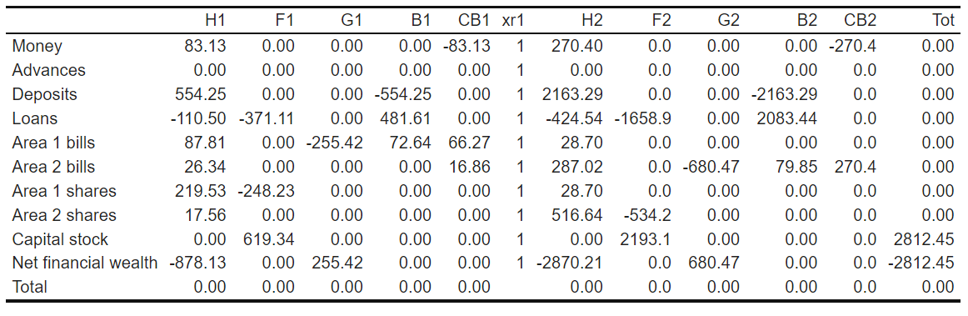

Table B.2.2. Transactions-flow matrix in period 75 (in current prices, in €10’s bi). Area 1 (European Union) and Area 2 (Rest of the World)

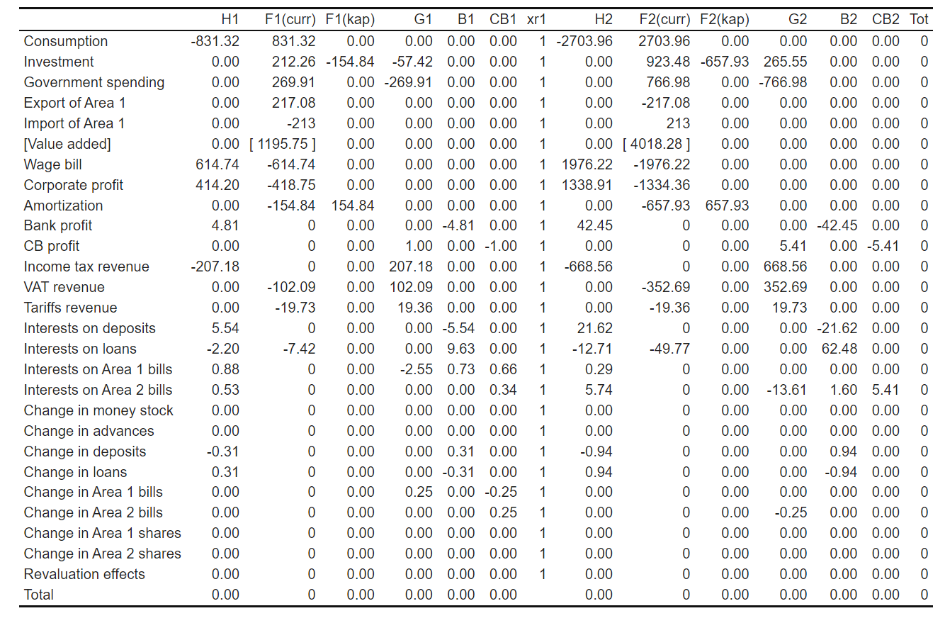

Table B.2.3. Multi-area input-output matrix in period 75 (current prices, in 10’s billions of EU)

|  | Area 1 demand for inputs | | | | |  | Area 2 demand for inputs | | | | |  |  |  |
| --- | --- | --- | --- | --- | --- | --- | --- | --- | --- | --- | --- | --- | --- | --- |
|  | M | A | S | W | R |  | M | A | S | W | R | Final dem. | Output |  |
| Area 1 production |  |  |  |  |  |  |  |  |  |  |  |  |  |  |
| Manufacturing | 67.01 | 66.89 | 67.13 | 26.13 | 0.00 |  | 5.58 | 5.57 | 5.59 | 2.18 | 0.00 | 312.33 | 558.43 |  |
| Agriculture | 67.01 | 66.89 | 67.13 | 26.13 | 0.00 |  | 5.58 | 5.57 | 5.59 | 2.18 | 0.00 | 311.35 | 557.45 |  |
| Services | 67.01 | 66.89 | 67.13 | 26.13 | 0.00 |  | 5.58 | 5.57 | 5.59 | 2.18 | 0.00 | 313.31 | 559.41 |  |
| Waste manag. | 67.00 | 66.89 | 67.12 | 0.00 | 0.00 |  | 5.58 | 5.57 | 5.59 | 0.00 | 0.00 | 0.00 | 217.76 |  |
| Recycling | 0.00 | 0.00 | 0.00 | 0.00 | 0.00 |  | 0.00 | 0.00 | 0.00 | 0.00 | 0.00 | 0.00 | 0.00 |  |
| Area 2 production |  |  |  |  |  |  |  |  |  |  |  |  |  |  |
| Manufacturing | 5.58 | 5.57 | 5.59 | 2.18 | 0.00 |  | 67.01 | 66.89 | 67.13 | 26.13 | 0.00 | 312.33 | 558.43 |  |
| Agriculture | 5.58 | 5.57 | 5.59 | 2.18 | 0.00 |  | 67.01 | 66.89 | 67.13 | 26.13 | 0.00 | 311.35 | 557.45 |  |
| Services | 5.58 | 5.57 | 5.59 | 2.18 | 0.00 |  | 67.01 | 66.89 | 67.13 | 26.13 | 0.00 | 313.31 | 559.41 |  |
| Waste manag. | 5.58 | 5.57 | 5.59 | 0.00 | 0.00 |  | 67.00 | 66.89 | 67.12 | 0.00 | 0.00 | 0.00 | 217.76 |  |
| Recycling | 0.00 | 0.00 | 0.00 | 0.00 | 0.00 |  | 0.00 | 0.00 | 0.00 | 0.00 | 0.00 | 0.00 | 0.00 |  |
| Value added |  |  |  |  |  |  |  |  |  |  |  |  |  |  |
| ~ Compensation of employees | 128.65 | 128.41 | 128.89 | 46.55 | 0.00 |  | 128.65 | 128.41 | 128.89 | 46.55 | 0.00 |  |  |  |
| ~ G.O. surplus and mixed incomes | 139.41 | 139.18 | 139.64 | 86.27 | 0.00 |  | 139.41 | 139.18 | 139.64 | 86.27 | 0.00 |  |  |  |
| Taxes on production | 0.00 | 0.00 | 0.00 | 0.00 | 0.00 |  | 0.00 | 0.00 | 0.00 | 0.00 | 0.00 |  |  |  |
| Output | 558.43 | 557.45 | 559.41 | 217.76 | 0.00 |  | 558.43 | 557.45 | 559.41 | 217.76 | 0.00 |  |  |  |

Table B.2.4. Area-specific physical flow matrix in period 20 (matter = Gt, energy = EJ)

|  |  |  |  |  |  |  |  |
| --- | --- | --- | --- | --- | --- | --- | --- |
|  | Matter | | |  | Energy | | |
|  | Area 1 | Area 2 | Global |  | Area 1 | Area 2 | Global |
| Inputs |  |  |  |  |  |  |  |
| Extracted matter | 442.69 | 4967.12 | 5409.81 |  |  |  |  |
| Recycled socio-economic stock | 26.03 | 182.24 | 208.27 |  |  |  |  |
| Renewable energy |  |  | 0 |  | 1628.69 | 6124.06 | 7752.75 |
| Non-renewable energy | 25.04 | 87.86 | 112.91 |  | 9971.55 | 37619.2 | 47590.74 |
| Oxygen | 66.86 | 234.6 | 301.46 |  |  |  |  |
| Outputs |  |  |  |  |  |  |  |
| Industrial CO2 emissions | -91.9 | -322.46 | -414.37 |  |  |  |  |
| Discarded socio-economic stock | -111.88 | -911.21 | -1023.09 |  |  |  |  |
| Dissipated energy |  |  |  |  | -11600.24 | -43743.25 | -23200.48 |
| Δ in socio-economic stock | 356.84 | 4238.15 | 4594.99 |  |  |  |  |
| Difference | 0 | 0 | 0 |  | 0 | 0 | 0 |

Table B.2.5 Global physical stock-flow matrix in period 20 (matter = Gt, energy = EJ)

|  |  |  |  |  |
| --- | --- | --- | --- | --- |
|  | Material reserves | Energy reserves | CO2 concentration | Socio-economic stock |
| Initial stock | 23586028.53 | -3243287.67 | 29526.45 | 355113.85 |
| Resources converted into reserves | 187918.58 | 1302.72 |  |  |
| CO2 emissions |  |  | 414.37 |  |
| Production of material goods |  |  |  | 5618.07 |
| Extraction/us of matter/energy | -5409.81 | -47590.74 |  |  |
| Destruction of socio-economic stock |  |  |  | -1023.09 |
| Final stock | 23768537.31 | -3289575.69 | 29940.82 | 359708.84 |
| Difference | 0 | 0 | 0 | 0 |

Figure B.2.1 Sankey diagram of cross-sector transactions and changes in stocks in $t=75$

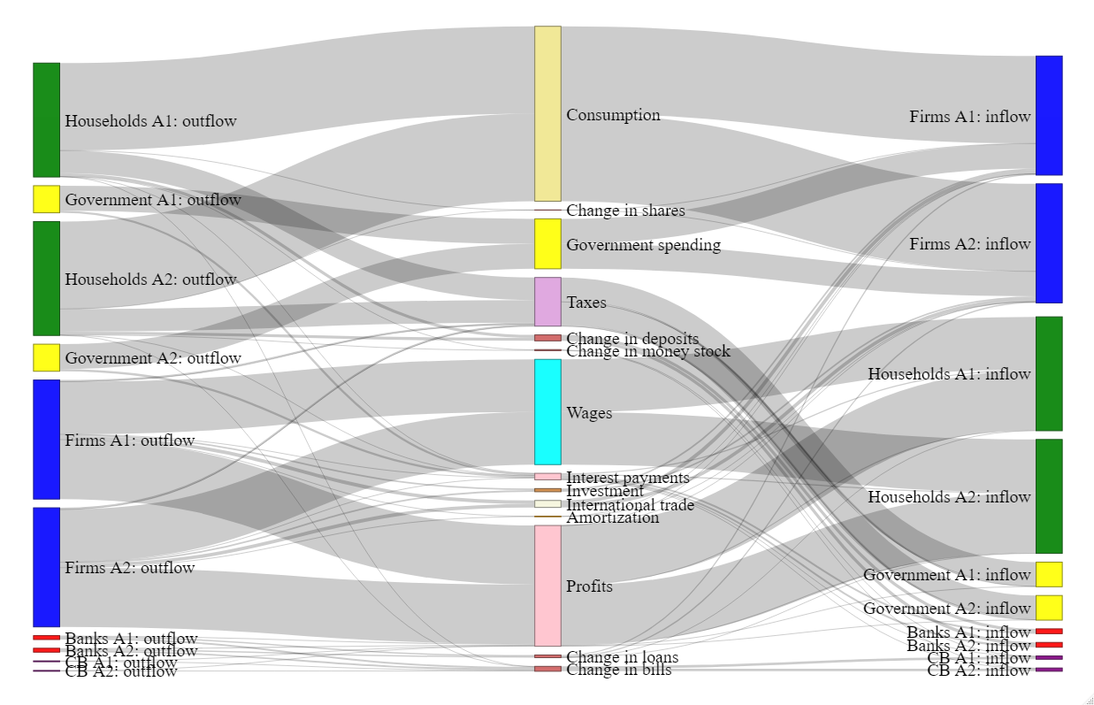

Figure B.2.2. Sankey diagram of cross-industry interdependencies in $t=75$

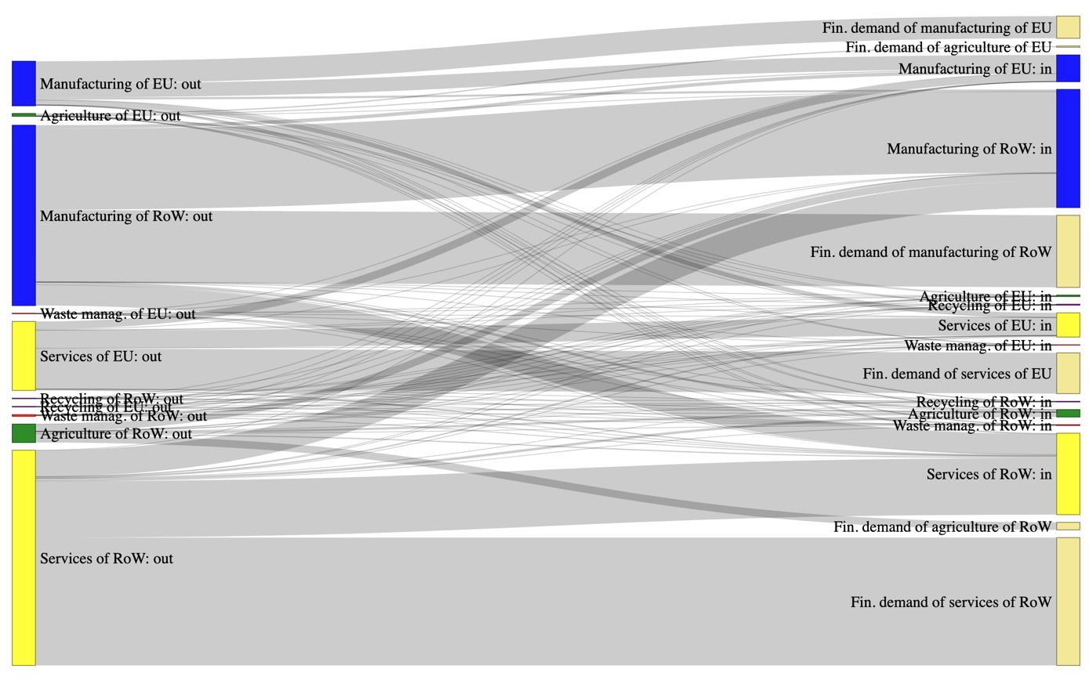

Figure B.2.3. Sankey diagram of material flows in $t=75$

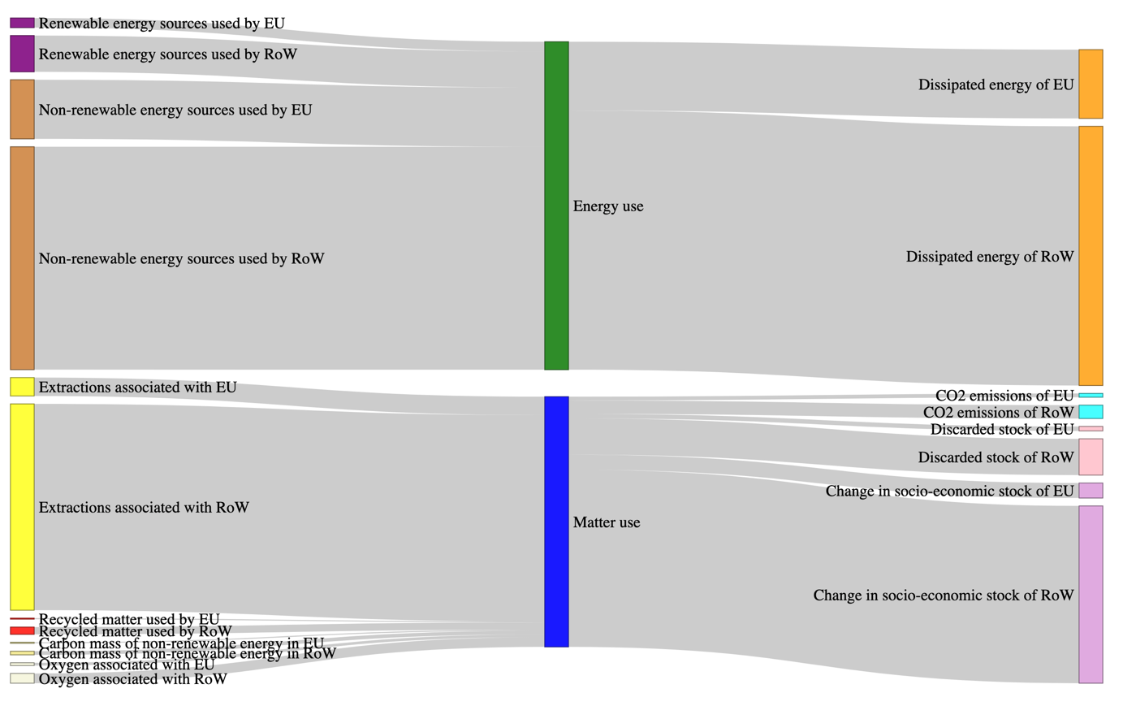

Appendix C– CE Scenarios

This section presents graphs of the evolution of main macroeconomic, labour market, and ecological variables included in the model for each shock.

[C.1] Shock 1

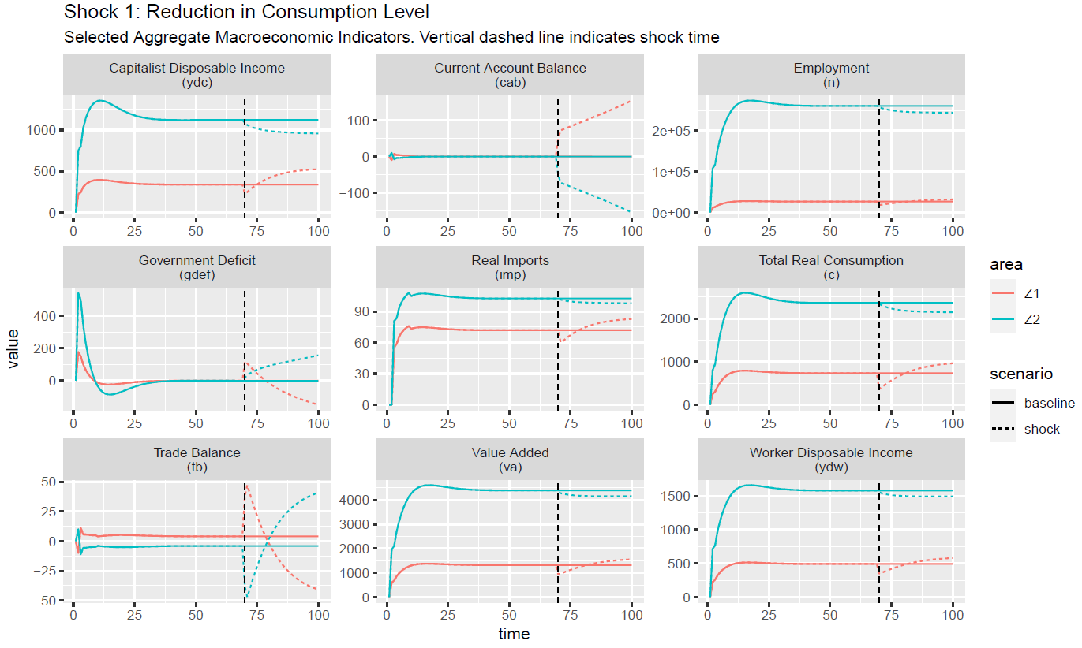

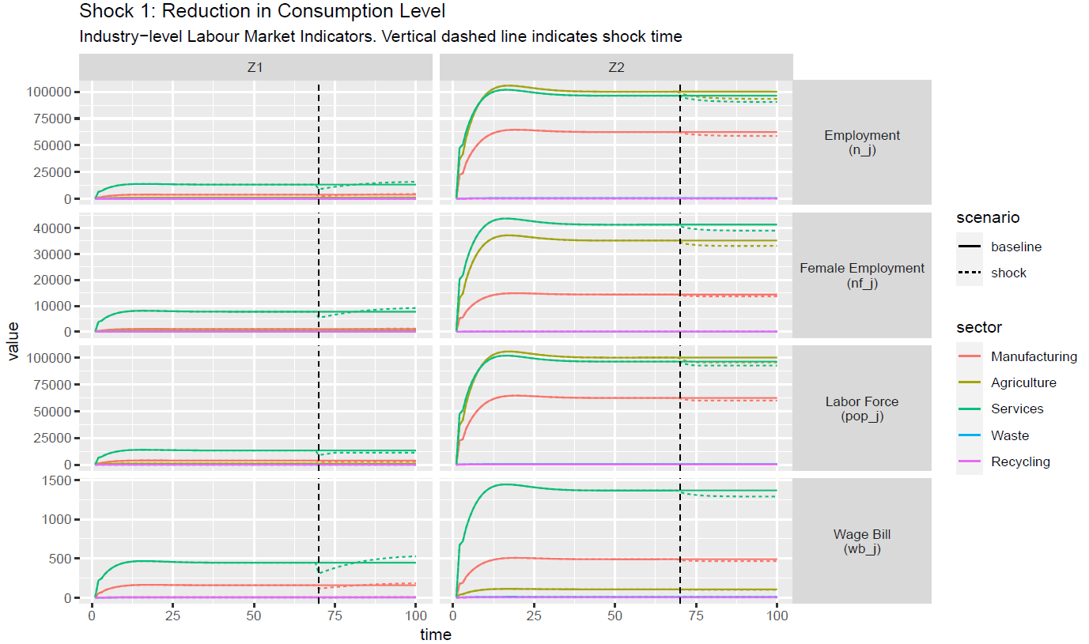

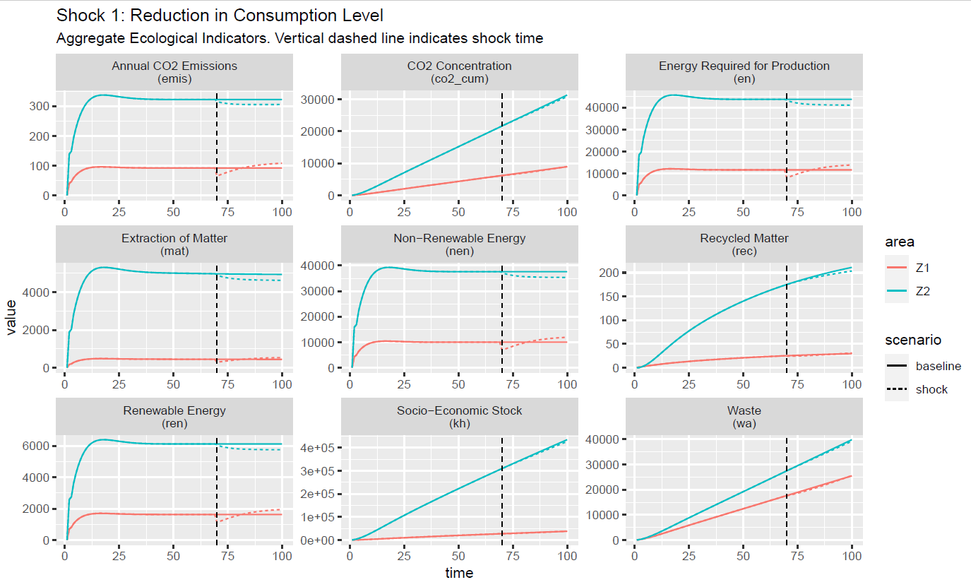

[C.2] Shock 2

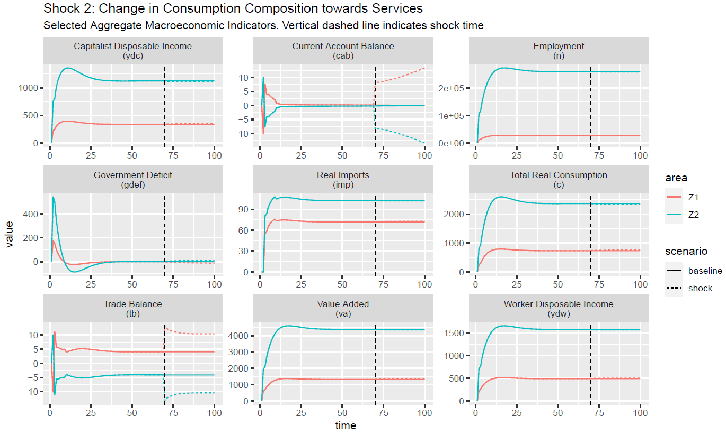

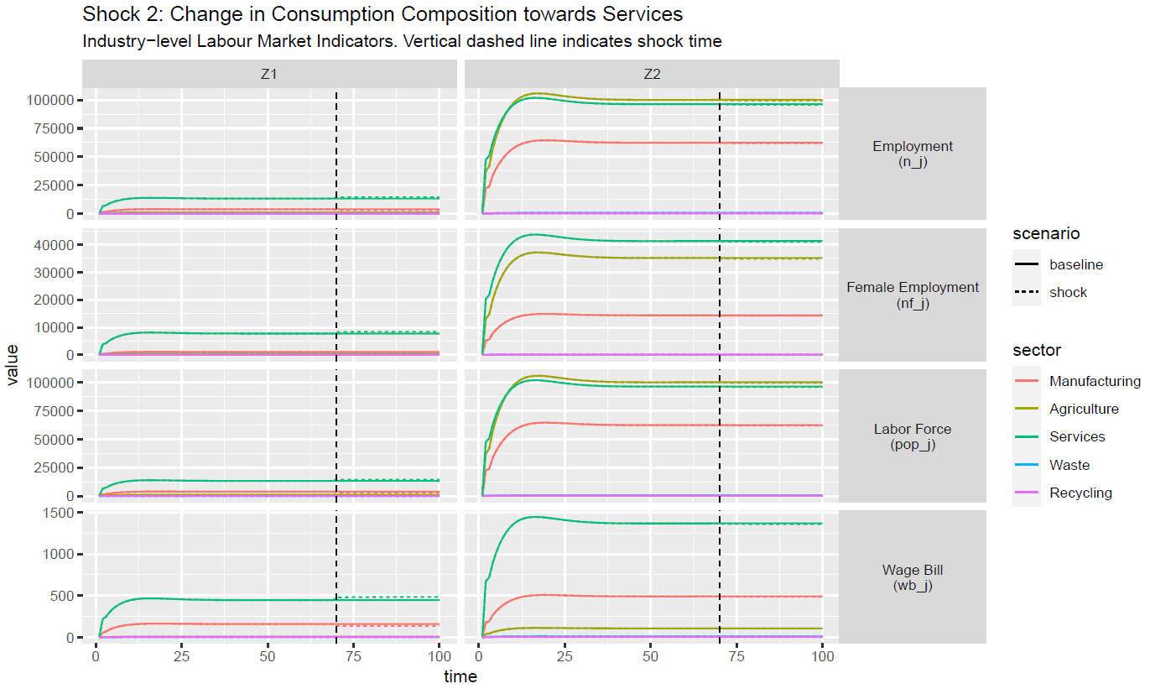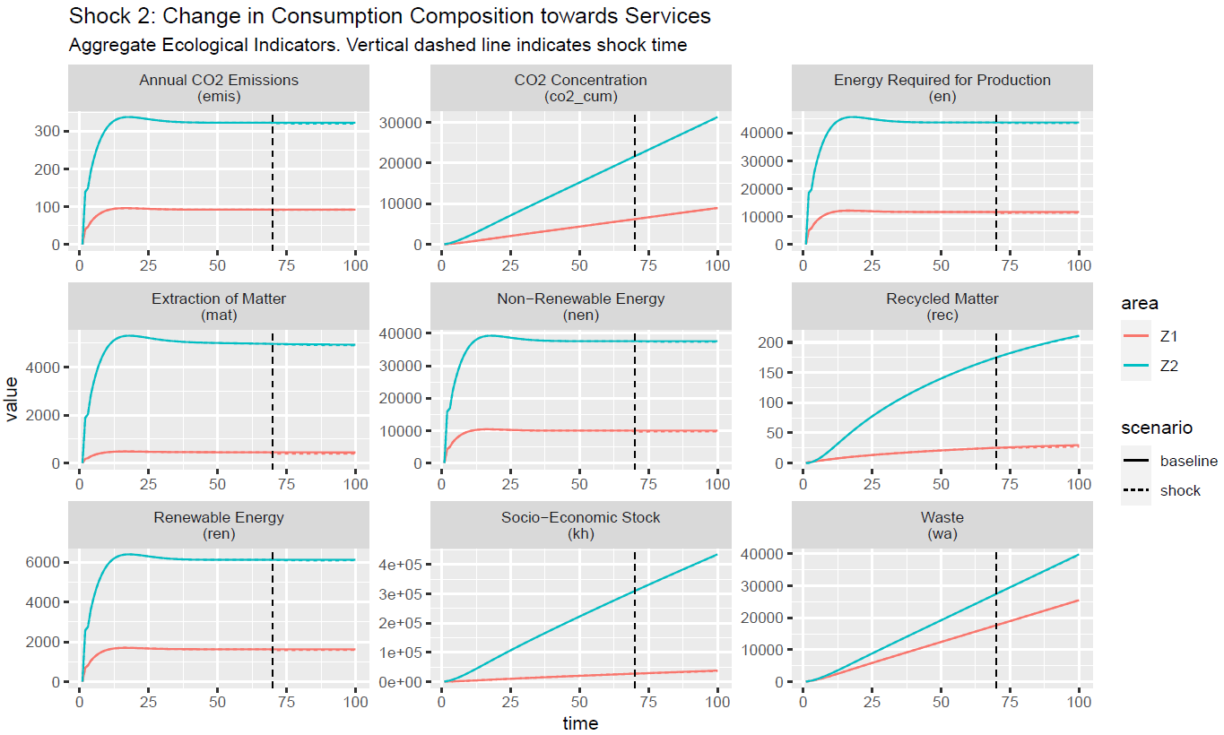

[C.2] Shock 3

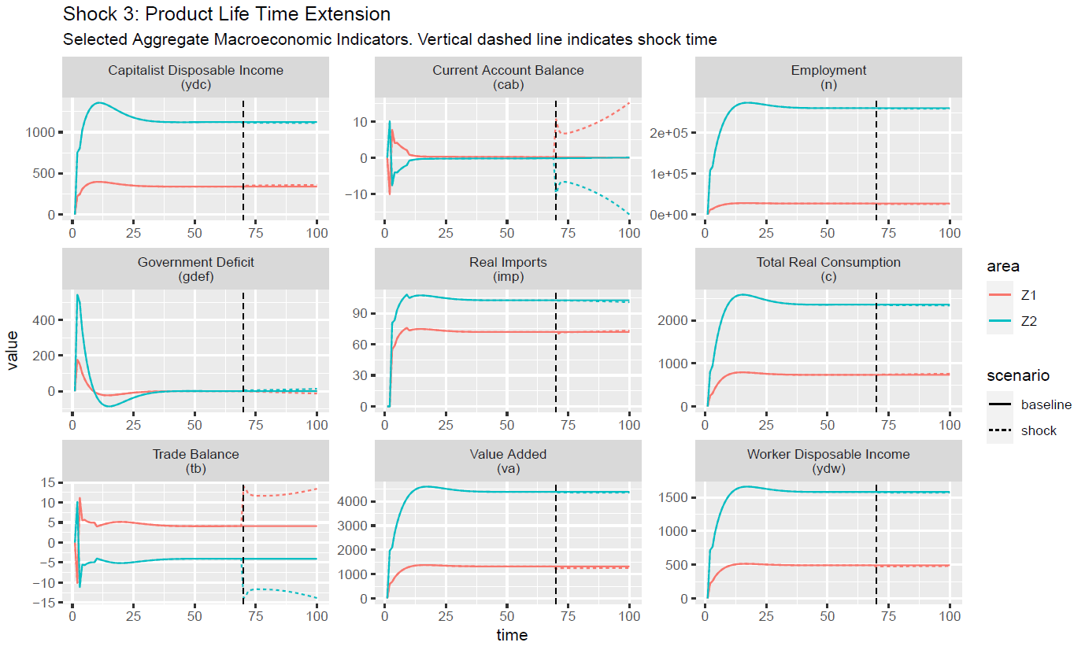

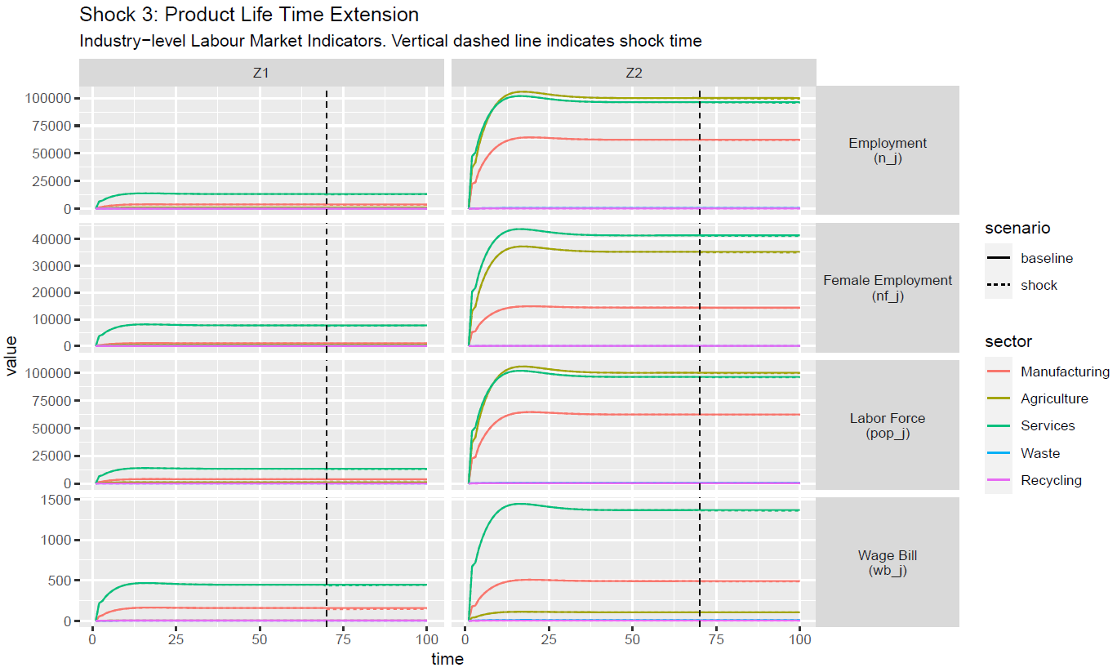

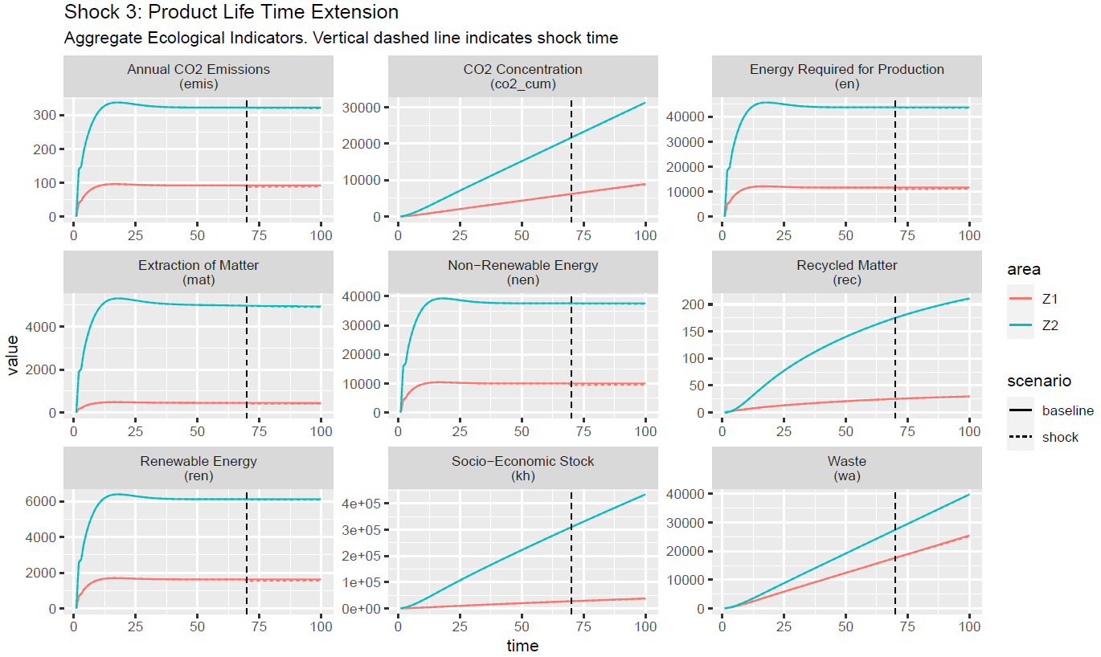

[C.4] Shock 4

 Figure 11: Shock 4



Figure 12: Shock 4



Figure 13: Shock 4

[C.5] Shock 5

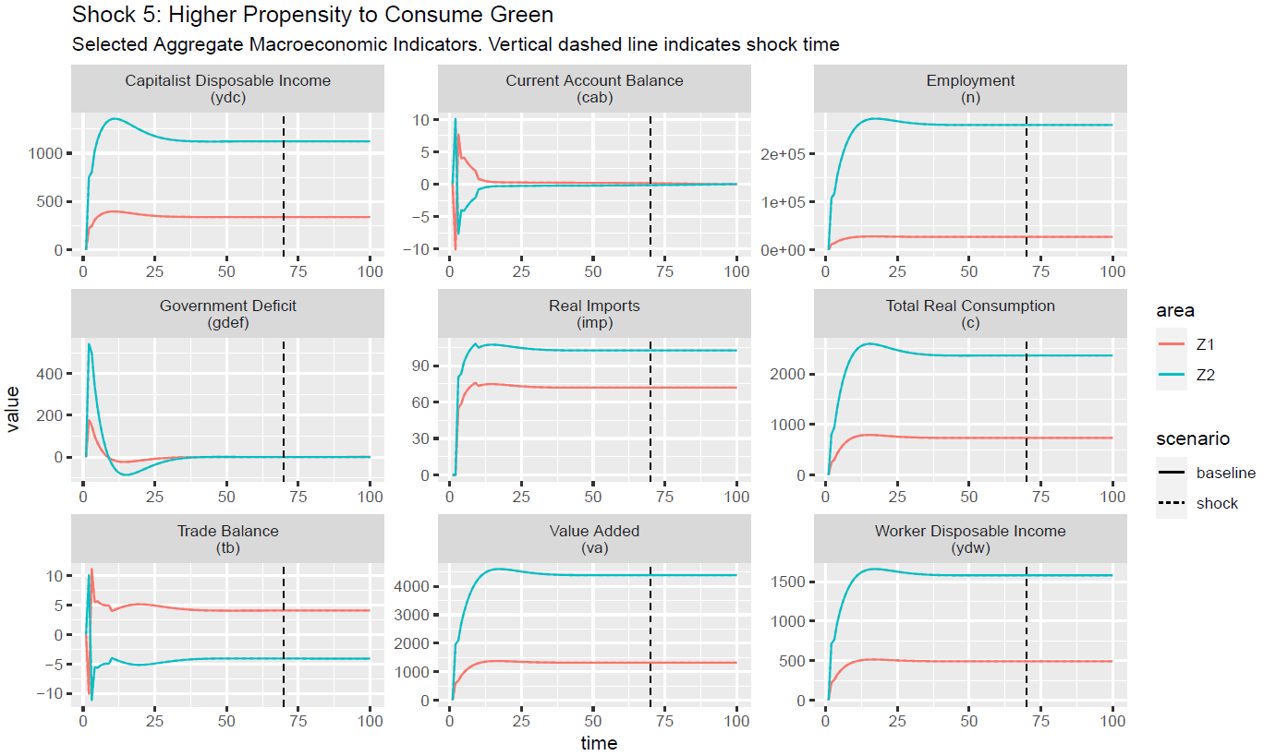

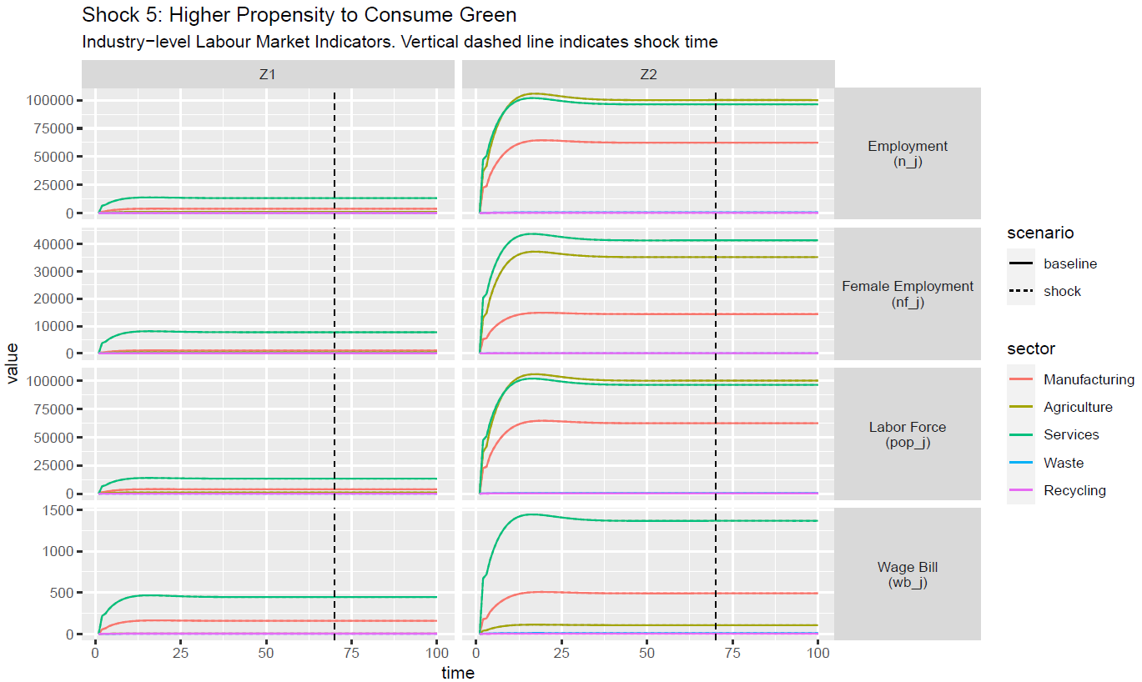

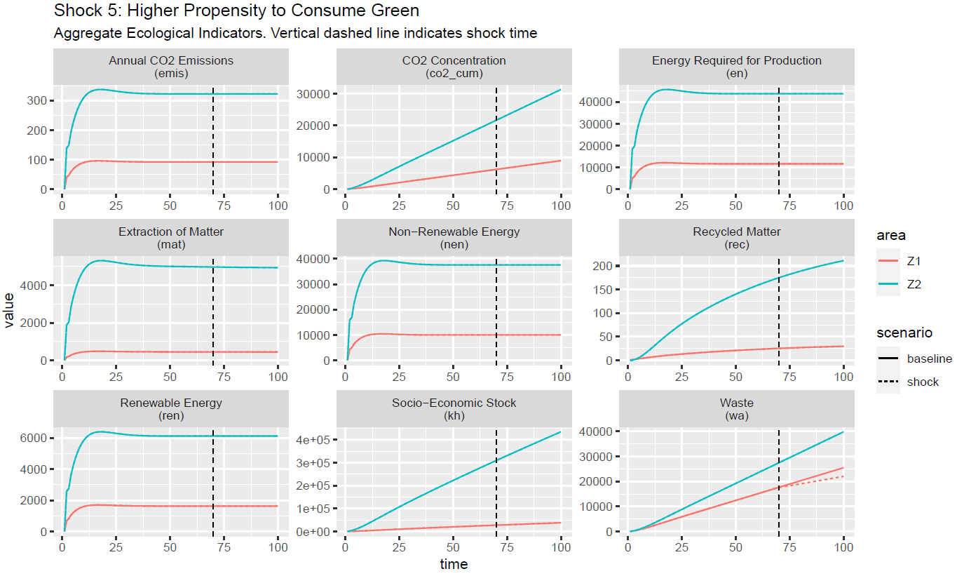

[C.6] Shock 6

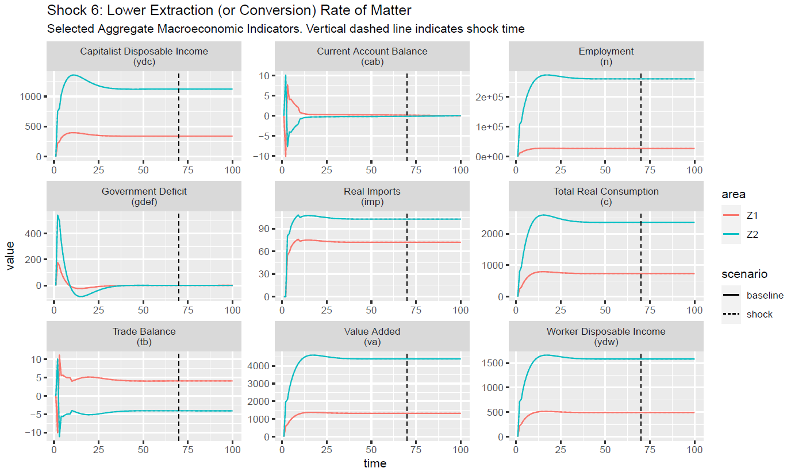

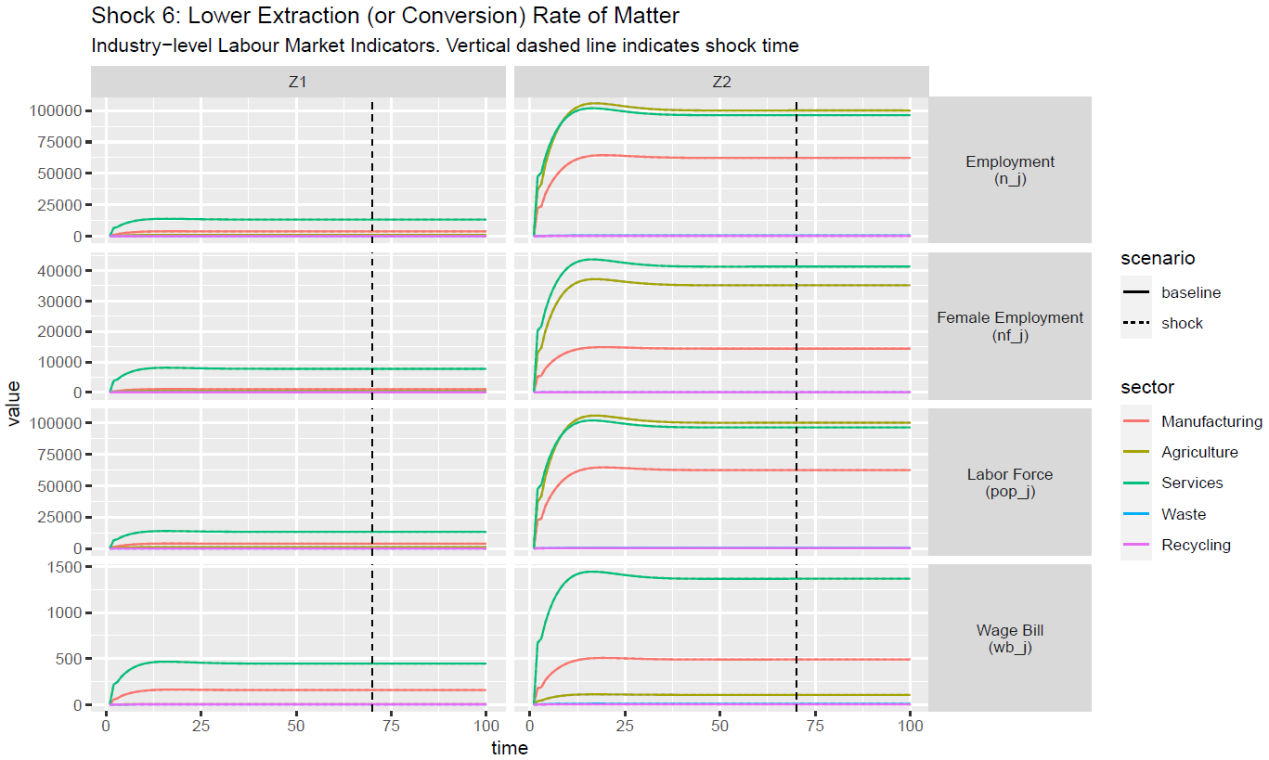

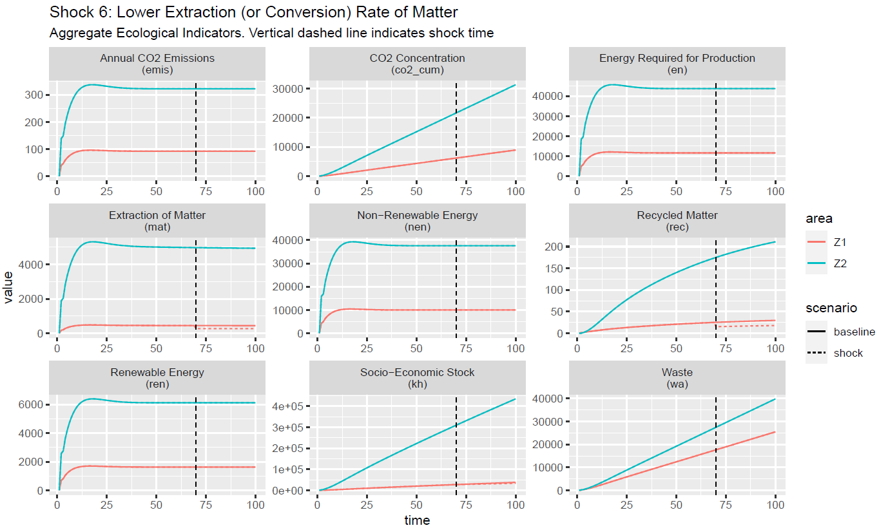

[C.7] Shock 7

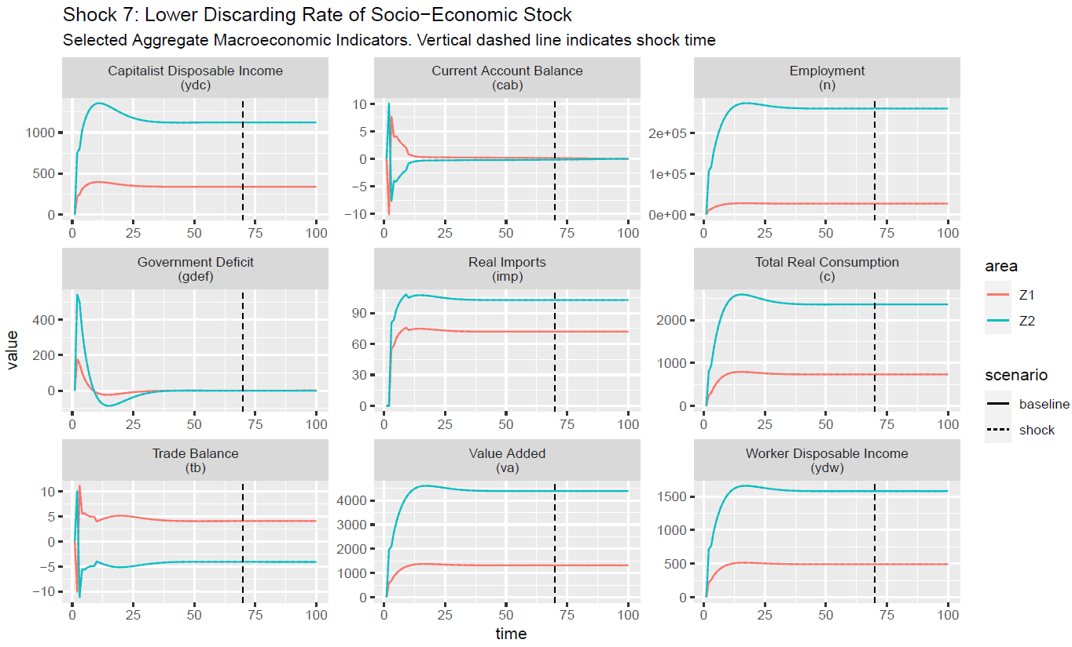

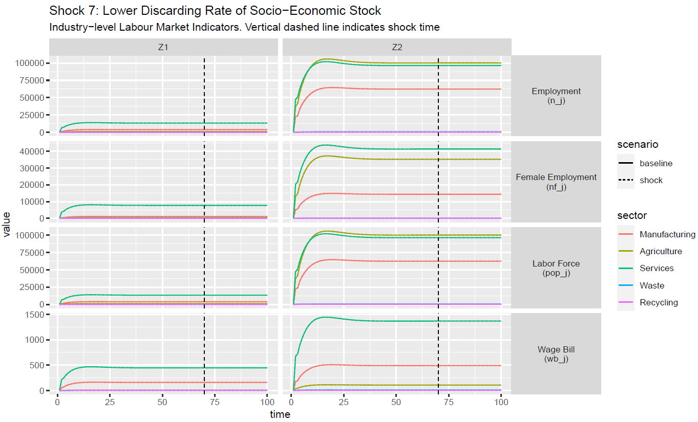

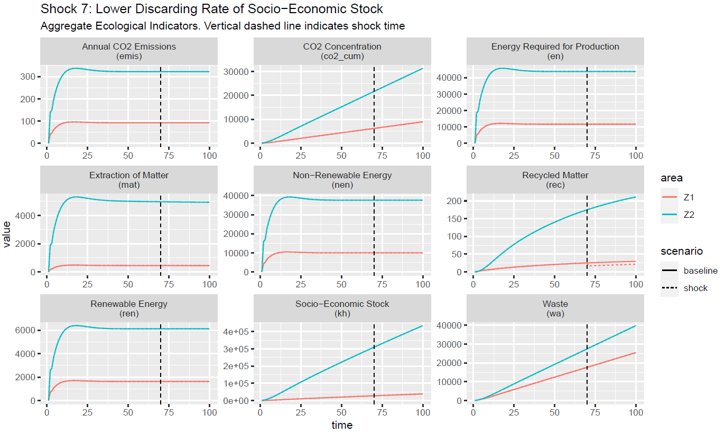

[C.8] Shock 8

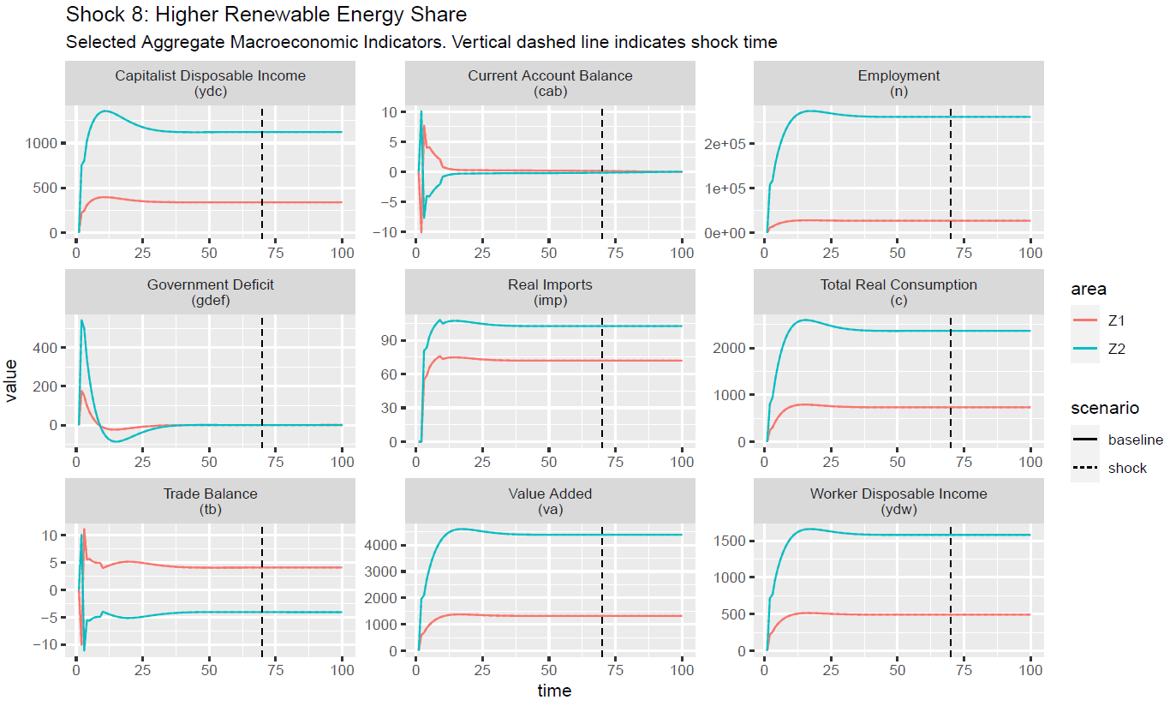

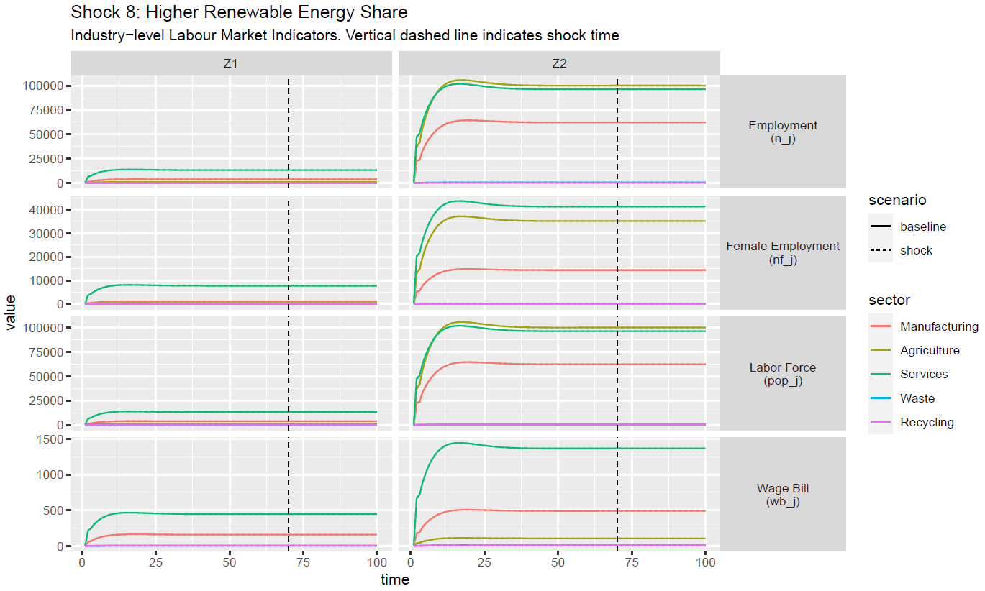

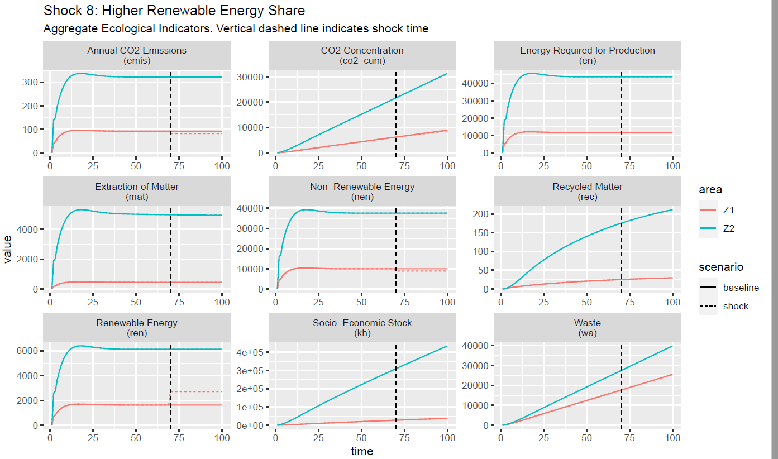

[C.9] Shock 9

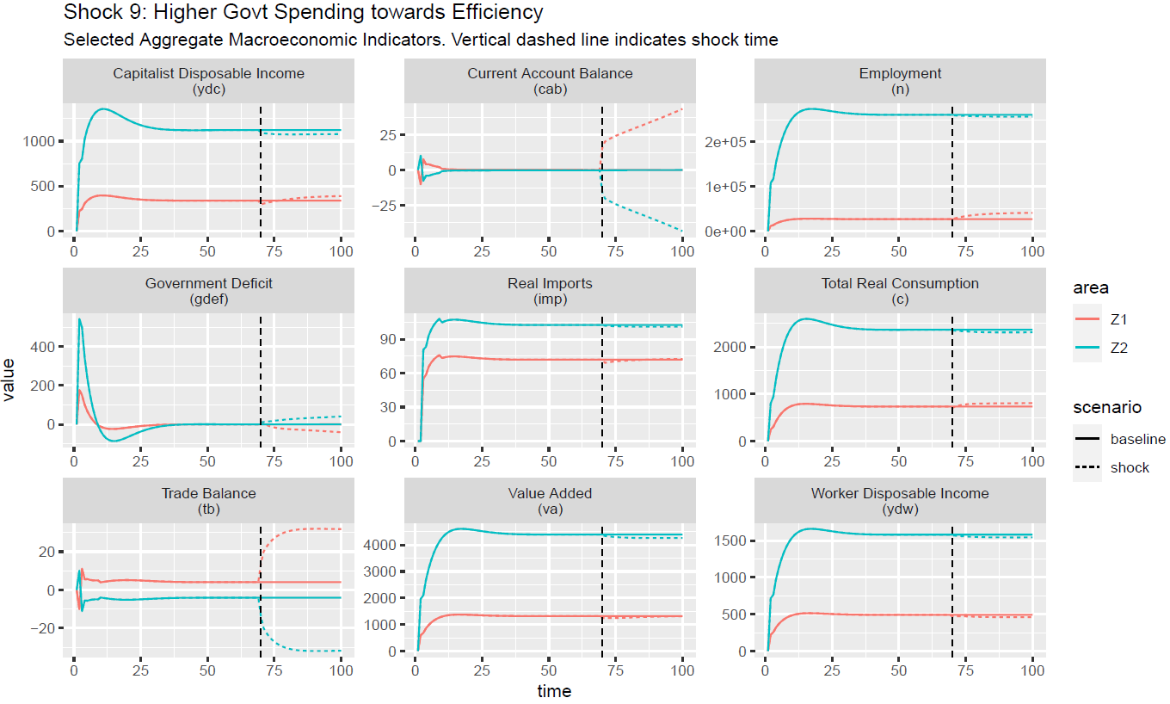

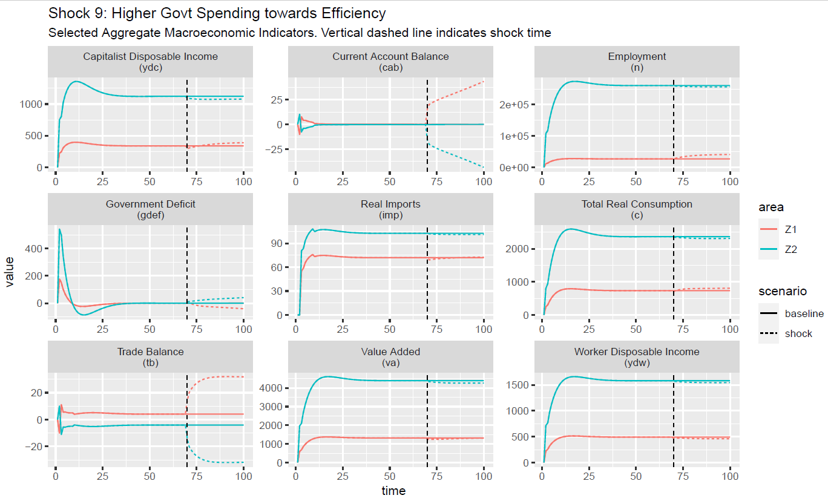

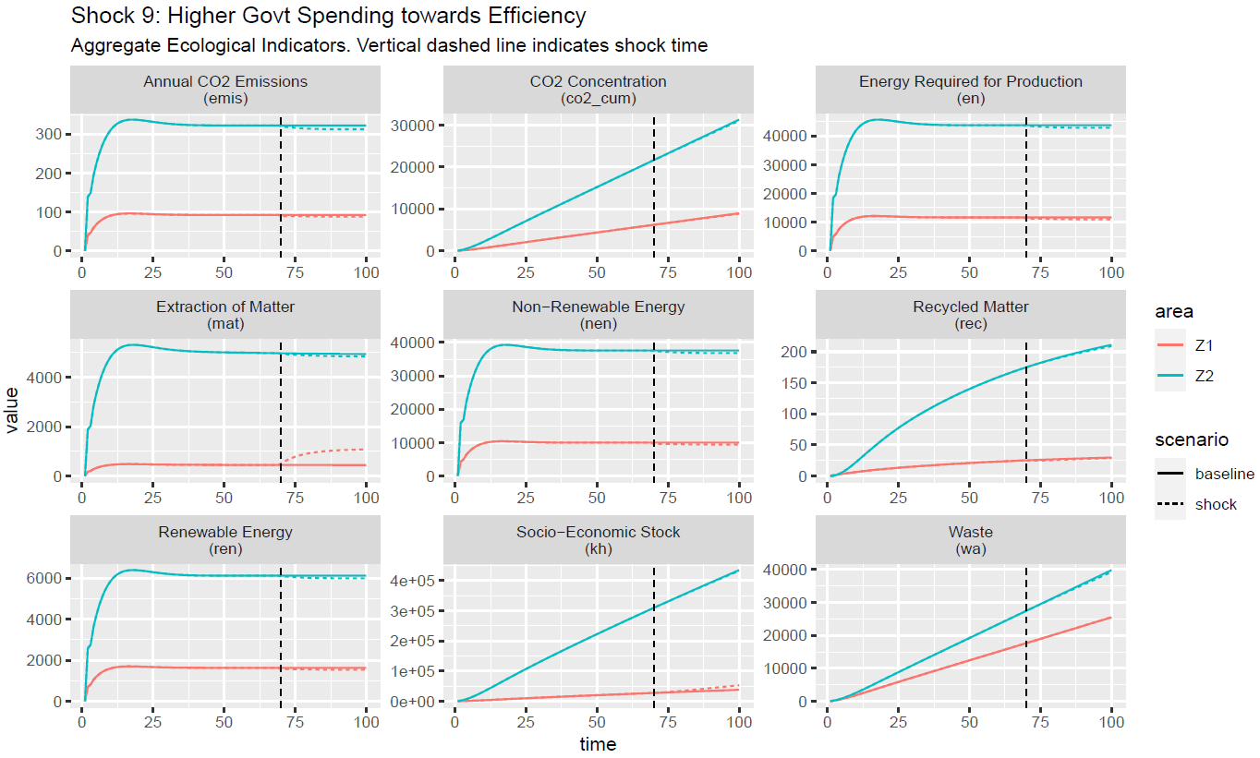

[C.10] Shock 10

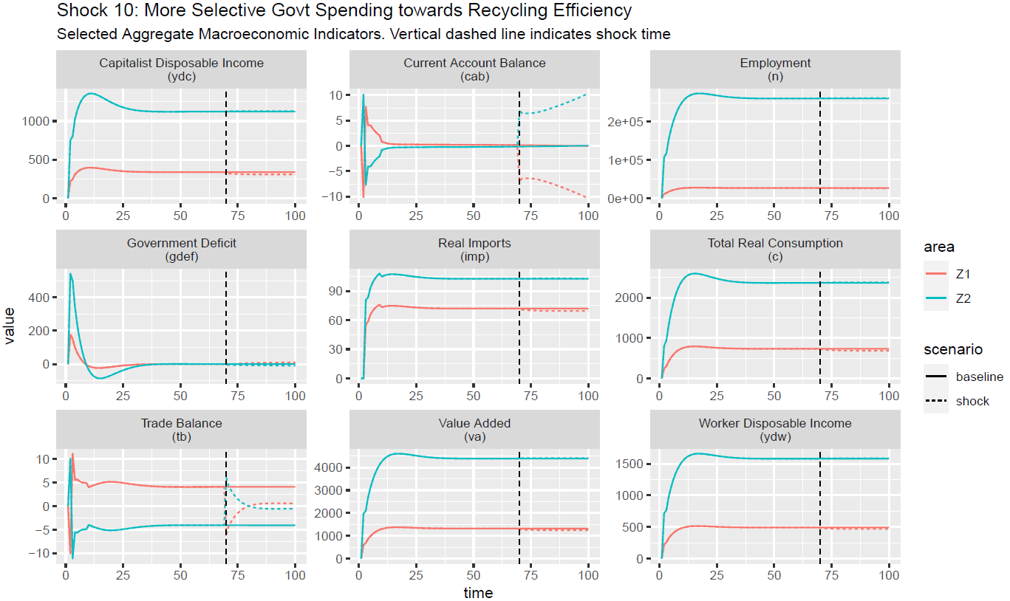

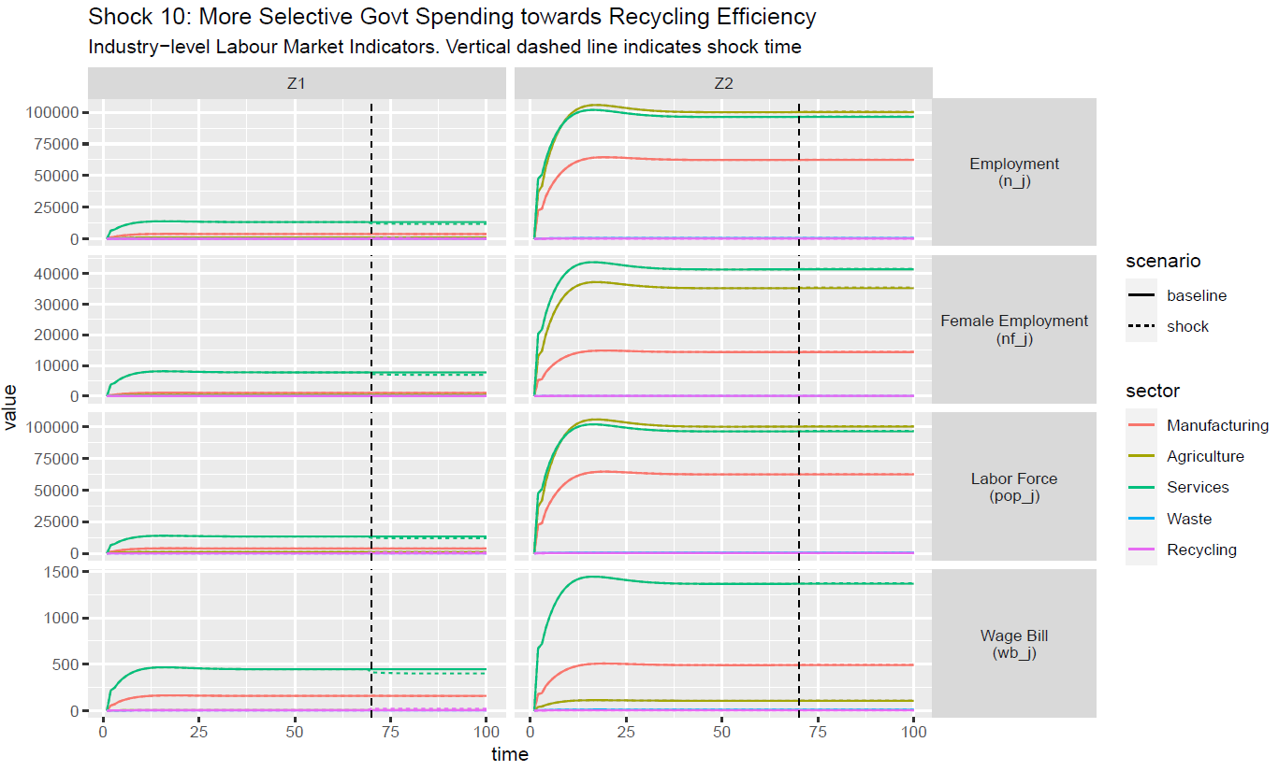

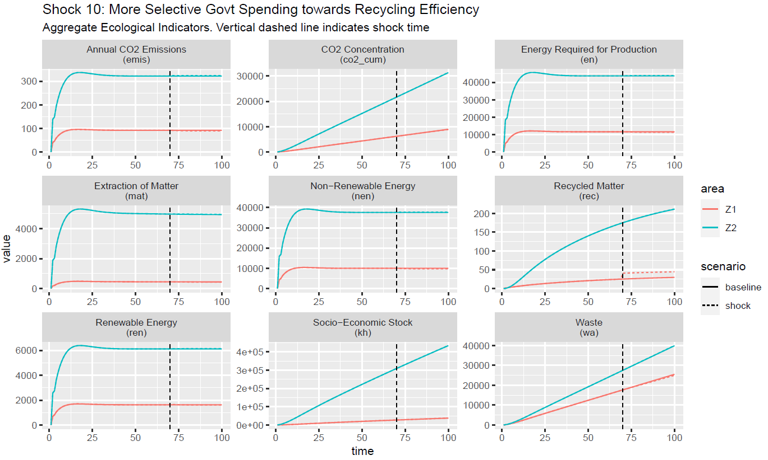

[C.11] Shock 11

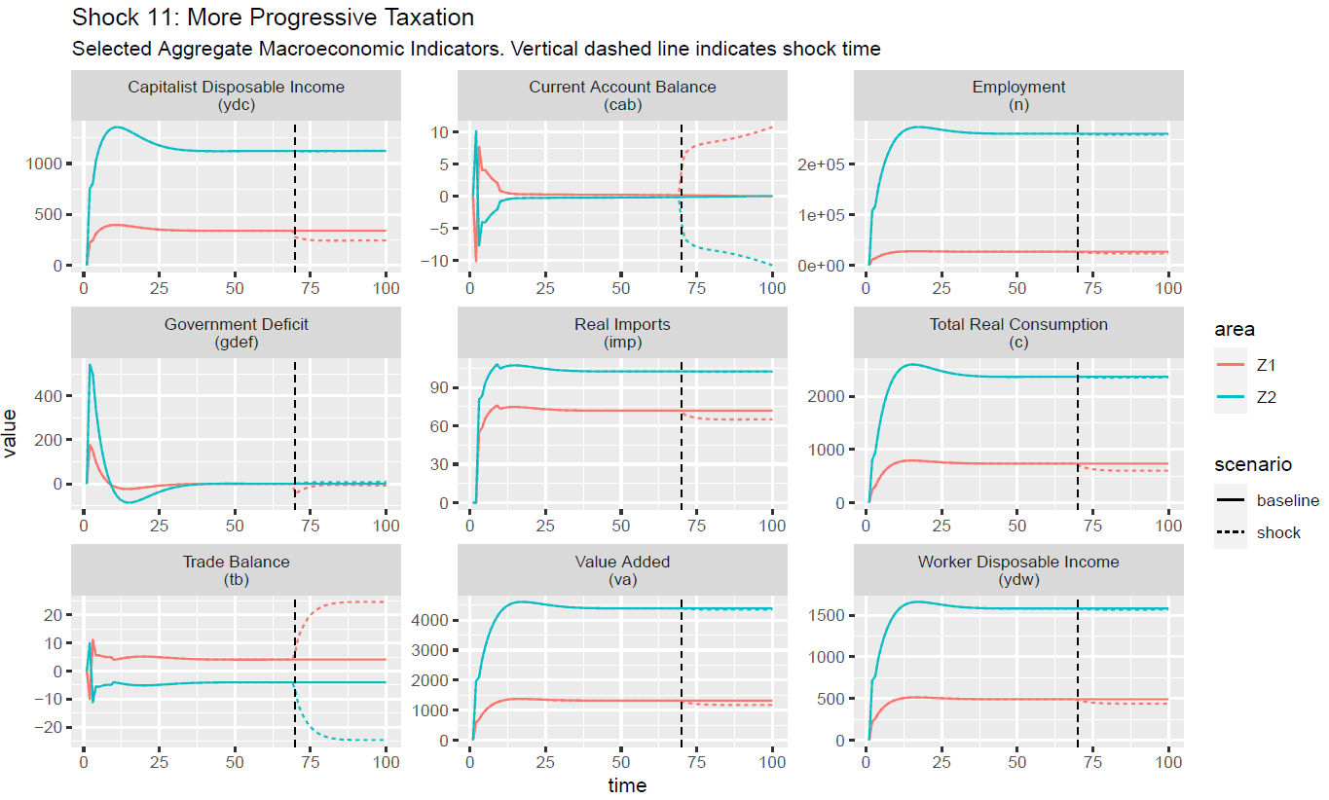

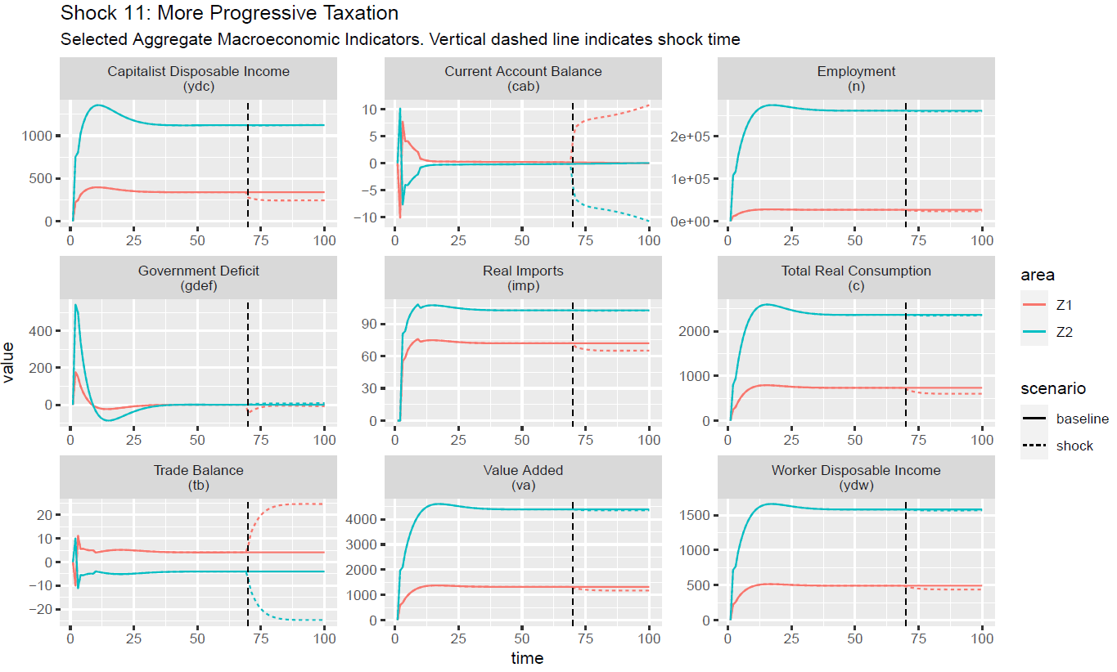

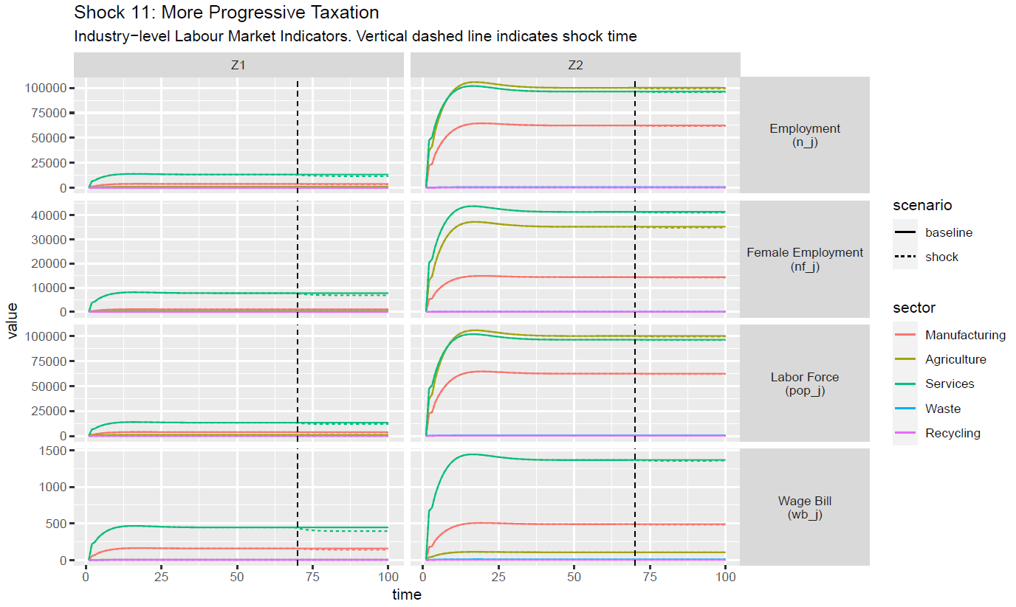



1. See Aguillar-Hernandez et al. (2021)for a meta-analysis.
2. The socio-economic stock of each economy is here defined as the quantity of durable goods that are available for the society.
3. A table with translator bet ween Exiobase 164-sectors and the 5-sector disaggregation used are provided in Appendix B.
4. , Purely adaptive price expectations are assumed in the baseline scenario, so that: $E\left(p_{A}^{z}\right)=p_{A,-1}^{z}$. Besides, the impact of the so-called ‘inflation tax’ on real disposable income is ignored.
5. Exchange rates are quoted indirectly. As a result, $xr^{z}$ is the price of one unit of domestic currency expressed in foreign currency, whereas, for the ‘home’ area, $xr^{f}$ is the price of one unit of foreign currency expressed in domestic currency.
6. For each area, the vector of export shares mirror the vector of import shares of the other area.
7. Notice that the term ${\left(\text{I}-\text{A}\right)}^{-1}$ is a matrix too. It is named the *Leontief inverse* and shows the multipliers, that is, the successive changes in production processes triggered by an initial change in final demands. As is well known, the Leontief inverse matrix can be expressed as a sum of power series (Waugh 1950[@fvw:1950]), that is: .
8. As we are explaining in subsection A.8, $p_{I}^{z}$ is the average price of investment goods and $p_{G}^{z}$ is the average price of goods purchased by the government sector.
9. Notice that $k^{*}$ cannot be expressed in physical units. It is calculated by dividing the nominal stock of capital by the average price of investment goods. See subsection 2.8.
10. However, it is assumed that $g_{g}^{z}=0$ in the baseline scenario.
11. Note that $⊙$ and $⊘$ are the Hadamard multiplication and division, respectively, also called element-wise multiplication and division of matrices.
12. Note that $λ$ s are defined in such a way that: *a*) horizontal constraints on coefficients of rates of interest/return for each financial asset are met; *b*) vertical constraints for cross-asset coefficients of rates of interest/return are met; and *c*) the sum of autonomous shares of assets to total wealth (additional vertical constraints) is lower than unity, because households can hold cash and bank deposits in addition to government bills and corporate equity (see Godley and Lavoie 2007, sections 5.6.2 and 5.6.3). These constraints must be verified at the global level.
13. We refer again to subsection 2.2.
14. It follows that actual marks-ups fall below normal mark-ups as long as $p_{j}^{z}<p_{j}^{z*}$, and they exceed them as long as , .
15. For the sake of simplicity, we assume away bank reserves.
16. In this scenario, the domestic central bank should be purchasing all the unsubscribed foreign bills to maintain exchange rate stability.
17. For a thorough discussion on the definition of CE, see Bimpizas-Pinis et al. (2021).
18. As CE innovation seems to imply some degree of input substitutability, one might notice that *smooth substitutability*, within the *same production function*, is one of the key assumptions of neoclassical general equilibrium models. However, input substitution is only possible here because of a *change in the techniques of production*.
19. Notice that: .